Physics Lab

Sanat Sachdev

Drone

I made a drone from scratch mostly and as it is known the first step to doing such a task is mentally prepare yourself and find the motivation to do so. My motivation was simply boredom, I have too much time to do nothing. Side note - after reading this lab you will know how little comprehension abilities I have.

Parts in no particular order:

1. 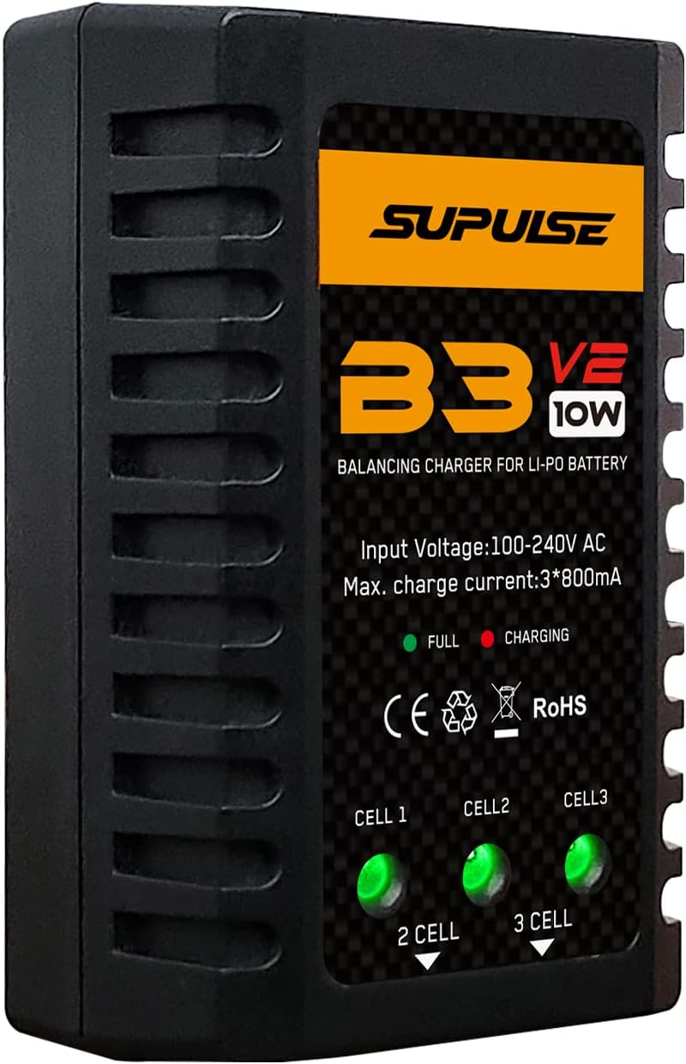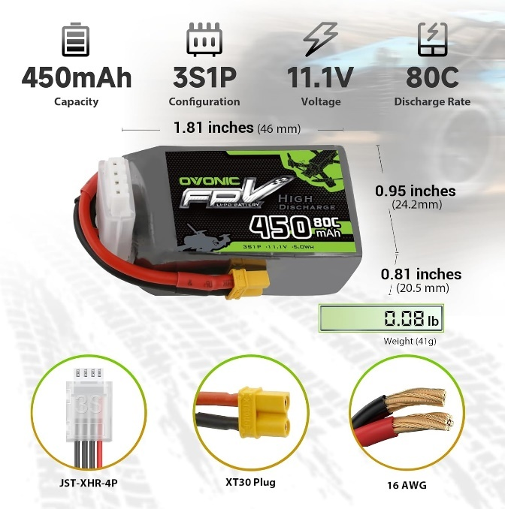11.1V Lippo Batteries and the charger (charger not sold with batteries)

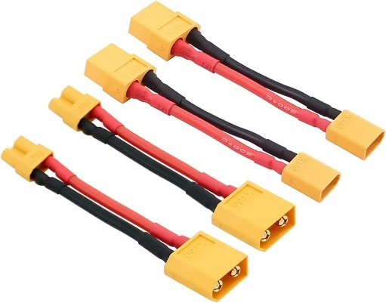Another side note – notice how it says XT30 Plug? Well, I didn’t and had to buy the following adapter.

1. XT30 – XT60 Adapter

Had to buy this simply because I couldn't read and on my 2nd attempt at buying a power distribution board – PDB (2nd attempt because the first one was too big) I bought the one with a XT60.

1. PDB (Power Distribution Board)

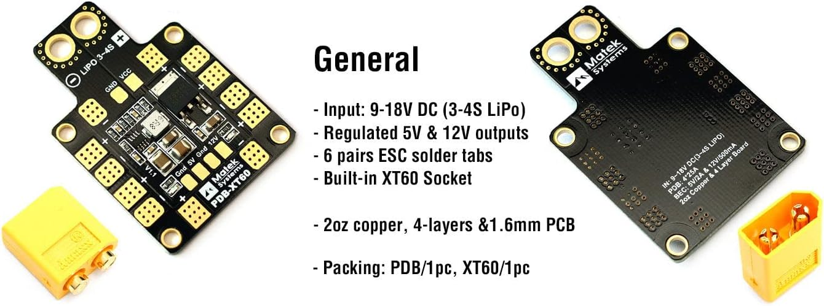

1. 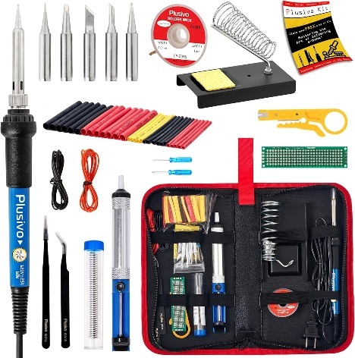Soldering Iron Kit

Needed this to solder which I learned that I am very bad at. You will find out about that later.

1. MPU9250 Board

This board is essential to keep the drone stable. This board lets you read the acceleration values in g-force, gyroscope values and magnetometer values.

1. 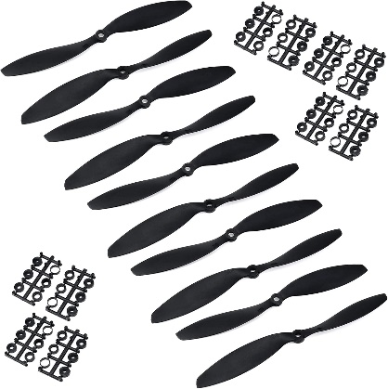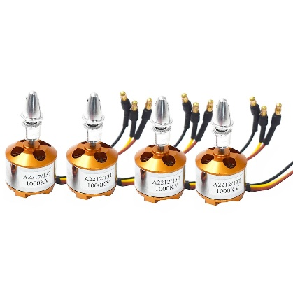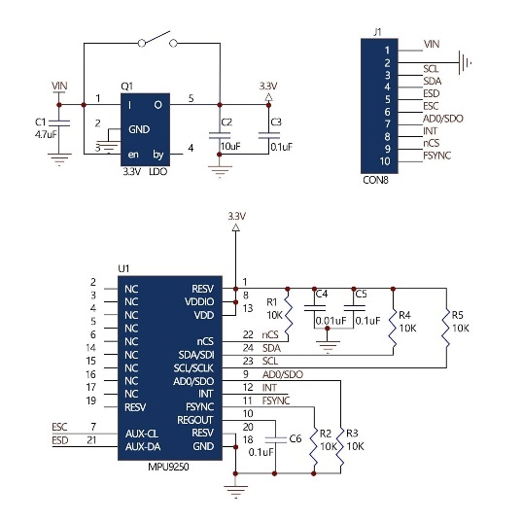Motors + propellers, needed to fly
2. 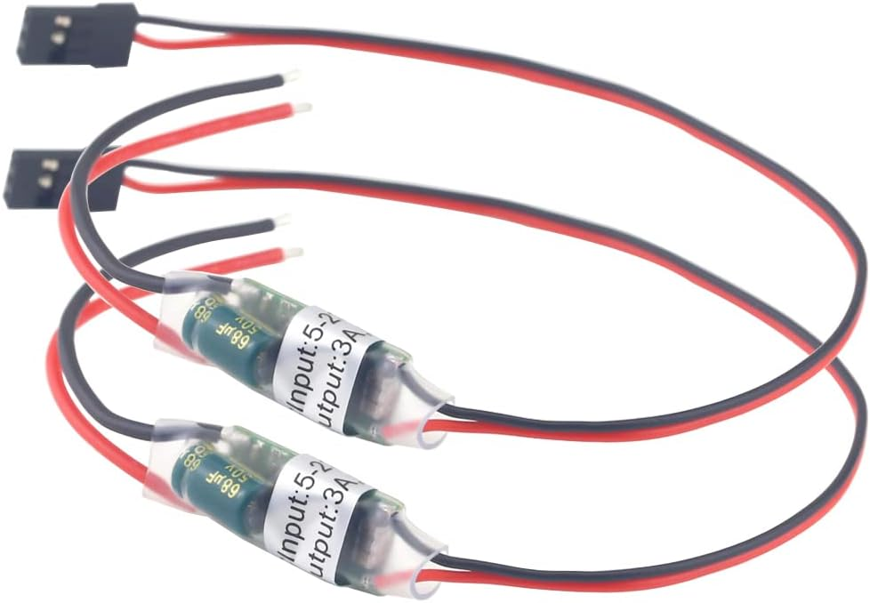UBEC 5V Wire

This is a wire used to transmit less voltage for my boards such as the STM32 and the Raspberry Pi 4 as those require 5V max. The battery provides 11.1V and this wire controls that to only send 5V.

1. Raspberry Pi 4 Model B

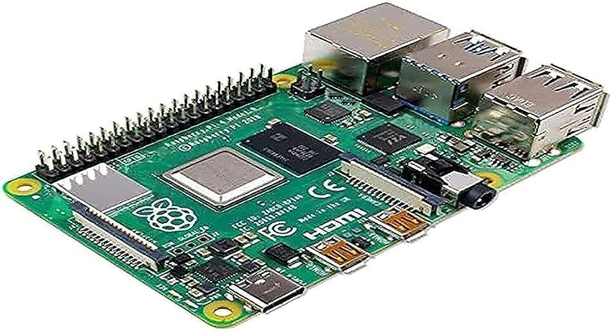This was needed to control the drone using a computer. The raspberry pi gets signals from the computer over Wi-Fi. Note the entire drone could be built without this if instead of using a computer to control the drone a remote controller was used. A SD card was also needed for the Pi to function.



1. 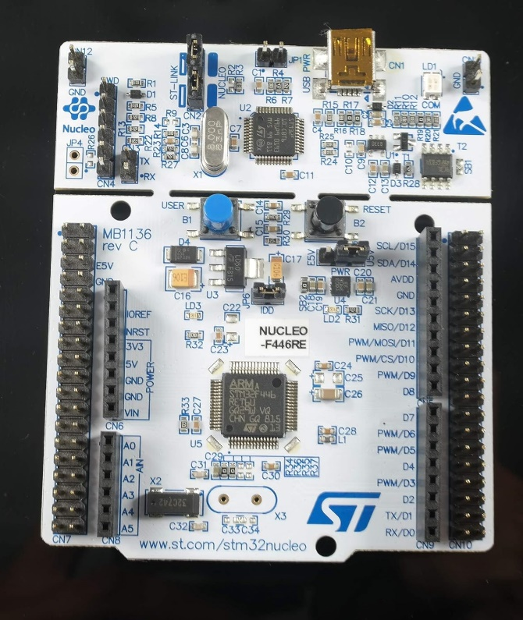STM 32 Board

This board controls the motors, main part of the drone.

1. 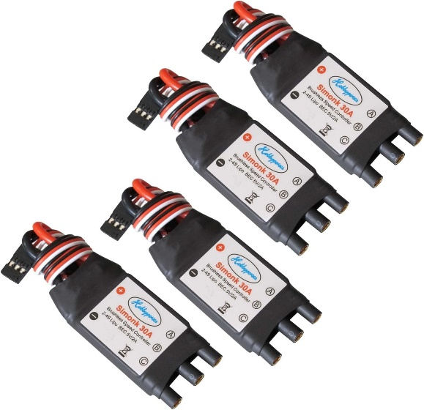Electronic Speed Controller (ESC)

This is needed to make the drone

move in a direction controlling

speeds of each motor.

1. Wires

I ran out of wires halfway through

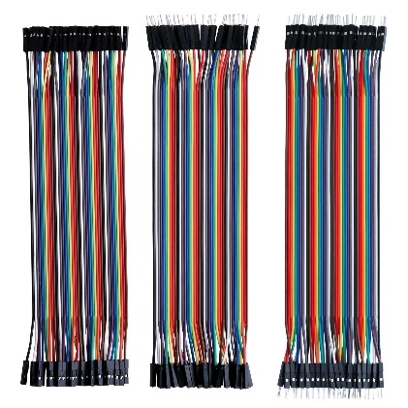and needed more,

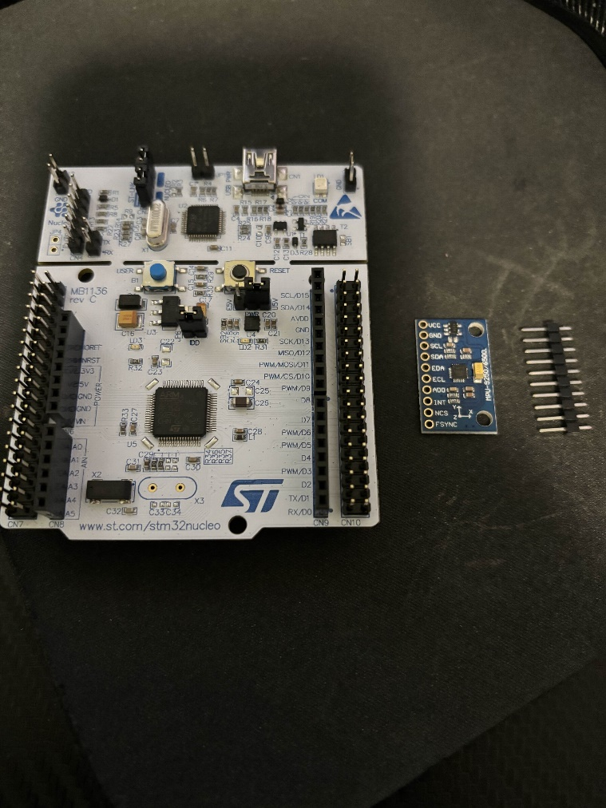

Building:

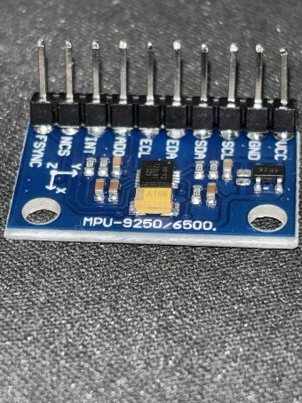To build a drone you have to start somewhere, I started with the STM32 board and the MPU9250. On the right is what the parts originally looked like; I had to solder the MPU9250 board (twice since I messed up the first time).

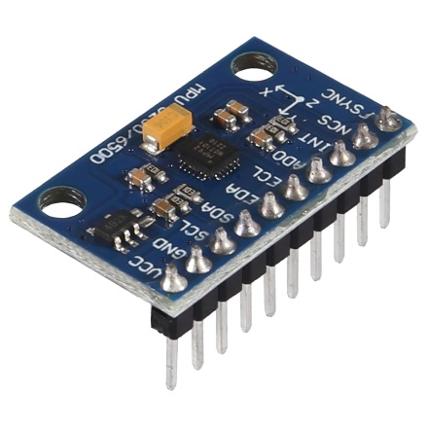

What it is supposed to look like

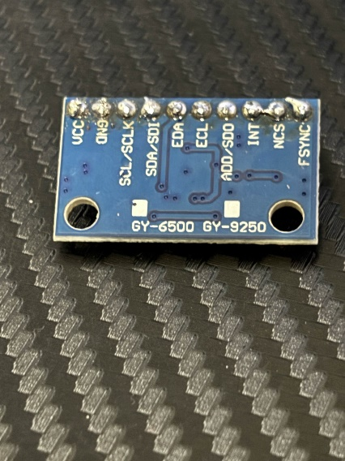

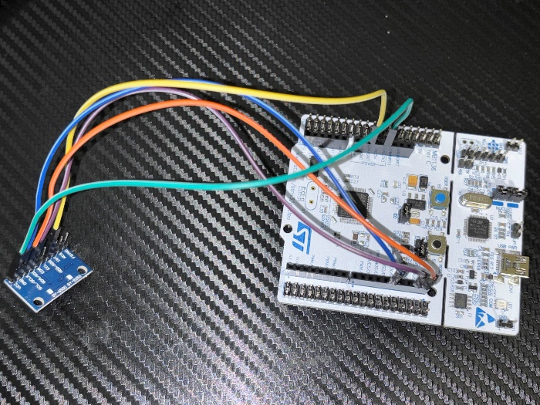So once I got that fixed it was time for the wiring. The MPU9250 connected to the STM32 with the following wired connections.

|  |  |
| --- | --- |
| **MPU9250** | **STM32** |
| VCC | 3V3 |
| GND | GND |
| SDA | D14 |
| SCL | D15 |
| AD0 | GND |

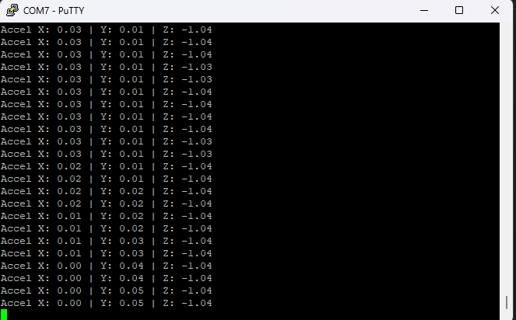This task alone wasted at least an hour because the STM32 board for the life of it could not get the device to register. The code obviously didn’t work on the first try because why would it. In the code it was supposed to print 0x71but it kept on printing 0x00 and only an hour later I realized I plugged in the MPU9250’s GND to the wrong GND on the STM32 (for some reason there are multiple GND ports on the STM32 and they have a mind of their own). However, finally it worked and printed the acceleration numbers in units of least significant bits (LSB). These are values from -32,768 to 32,767. In terms of g 16,384 is equal to 1g. So, by simply dividing the values by 16,384 you could figure out the drone’s (the board in this case) acceleration in g.

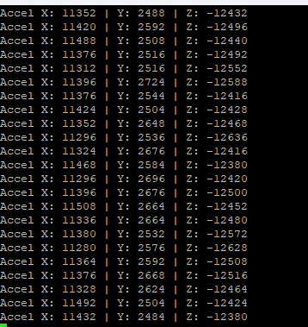

LSB To g

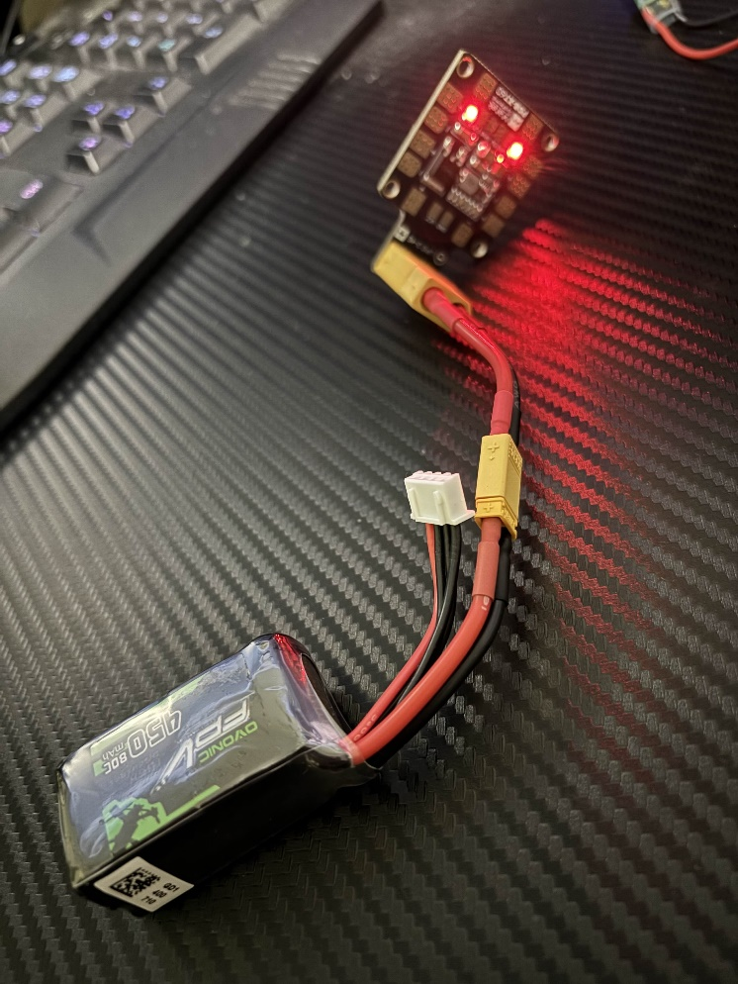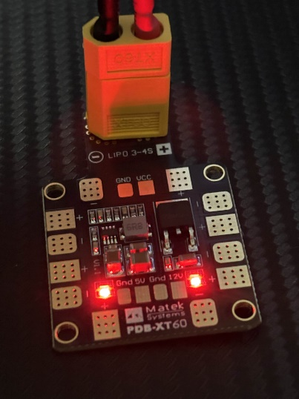After this huge accomplishment (which took place over 3 days as the soldering went wrong then I had to wait for new parts and try again) I decided to completely ignore the rest of the MPU9250 and decided to move onto the wiring and soldering for the raspberry pi. However to get the raspberry pi running I needed to power it and since I was too lazy to find a charger I decided to just solder the UBEC to the PDB since I had to later anyways.

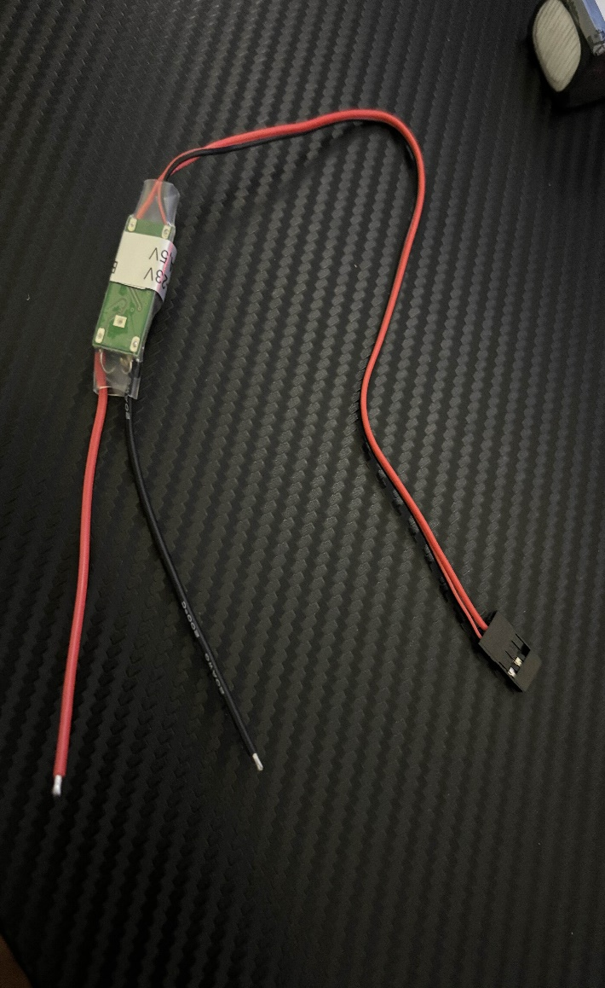In the previous image you can see the PDB connected to the 11.1V Lippo battery. However, the UBEC is needed to connect this to the raspberry pi as that only takes 5V max anymore would fry it so the UBEC wires had to be soldered on to the bronze plates you can see circled in the image below. The red wire goes to the positive while the black wire went to the negative.

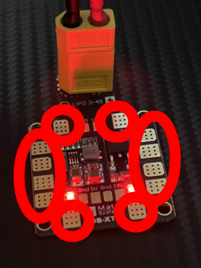

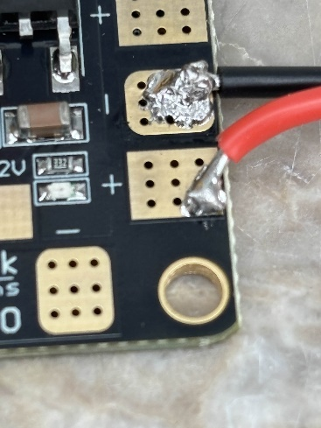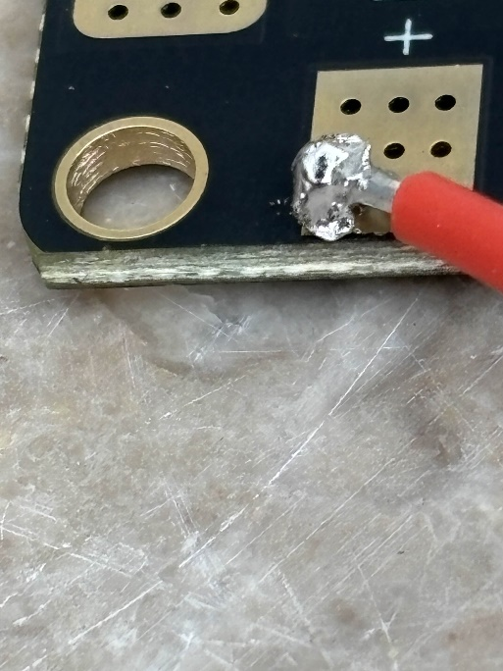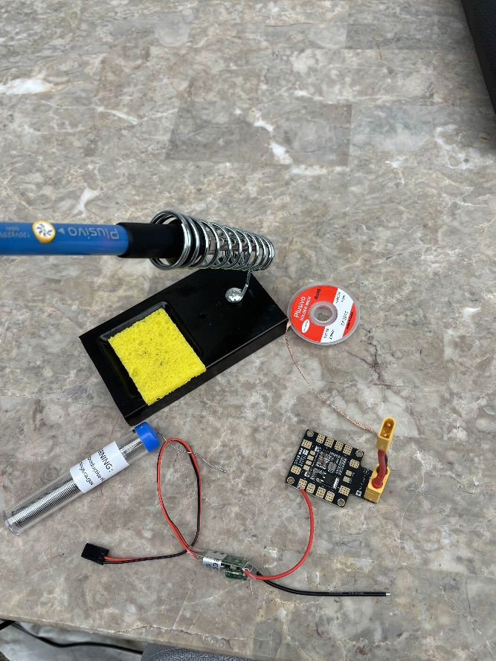Below are images of my soldering set up and the soldered wires.

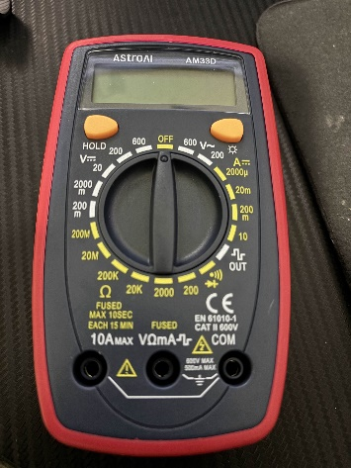

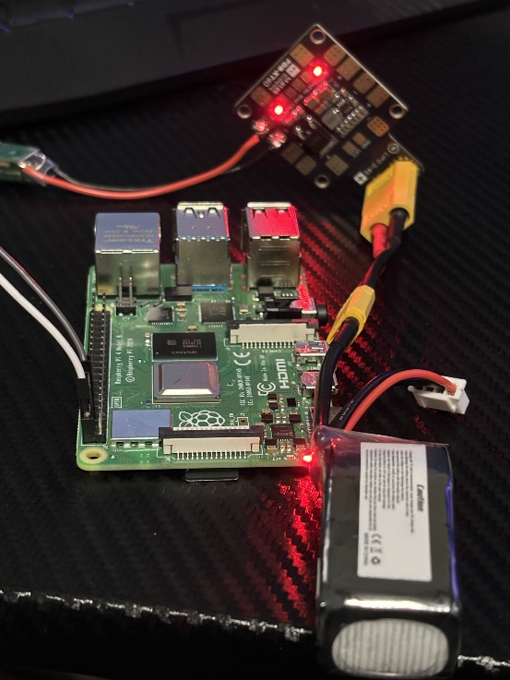I also used a multimeter to test the voltage at the end of the wires before and after soldering to make sure they matched and they did which was an actual miracle. To test before soldering I simply held the wires on the bronze plates. I do not have pictures of the actual multimeter reading (which was 5.2V) because to do so I would need another 3 arms.

On the left you can see the final with power being supplied to the raspberry pi using the external 11.1V Lippo battery.

To connect the UBEC to the raspberry pi I connected the black wire (grey in the image in the previous page, had to use another wire to connect from the UBEC to the raspberry pi) to the 6th pin on the pi and the red wire (white in the image) to the 2nd pin on the pi.

Downloading the software on the SD card was another hassle as my pc doesn’t have a slot for SD cards so I had to find my old laptop. Also remember how my memory sucks? Well, I forgot what password I set for the SD card 3 separate times so I had to reflash everything I downloaded on it multiple times until I finally got it right and connected to the raspberry pi.

This is a pinout for both the raspberry pi and the stm32 board I used to make sure my wiring was all right.

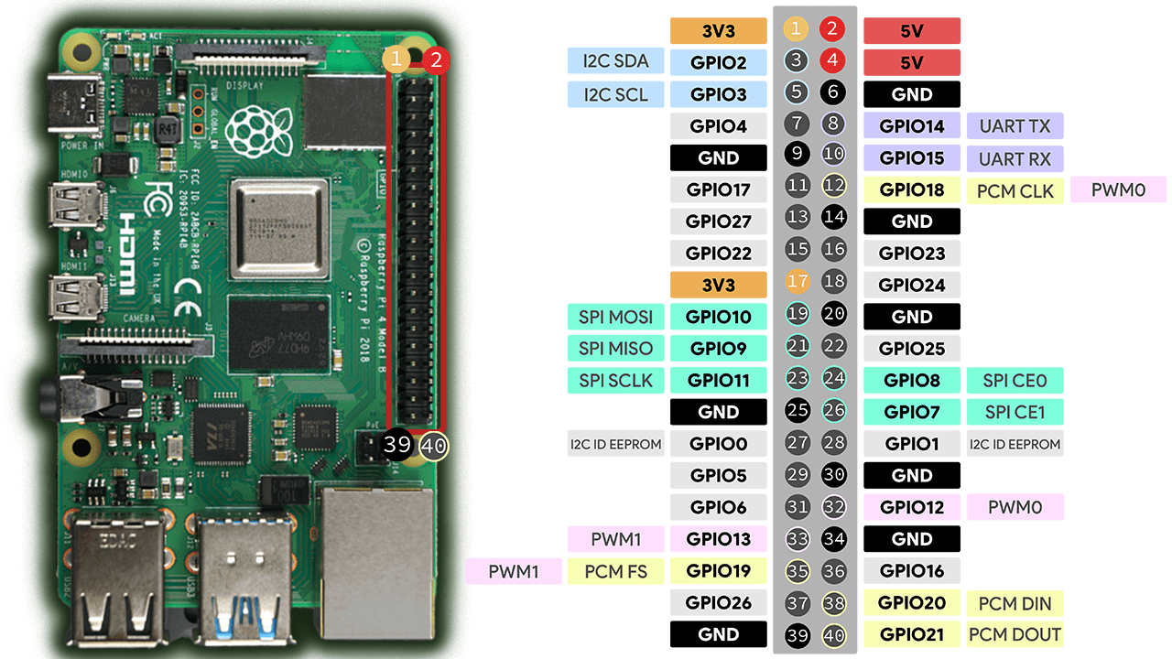

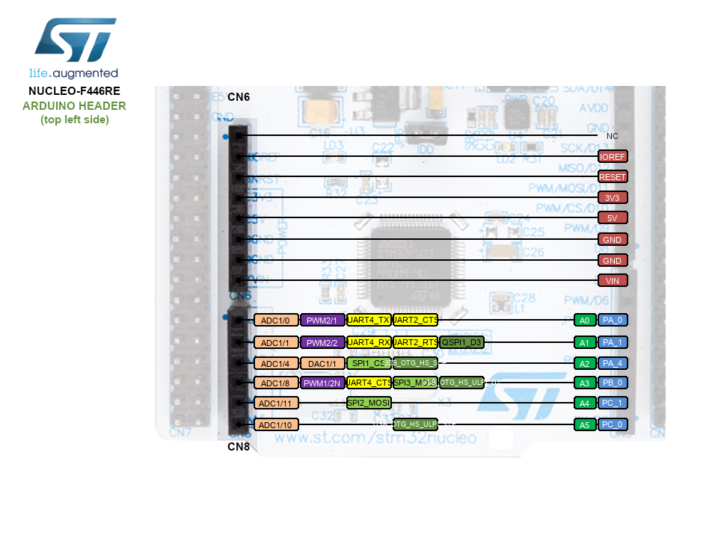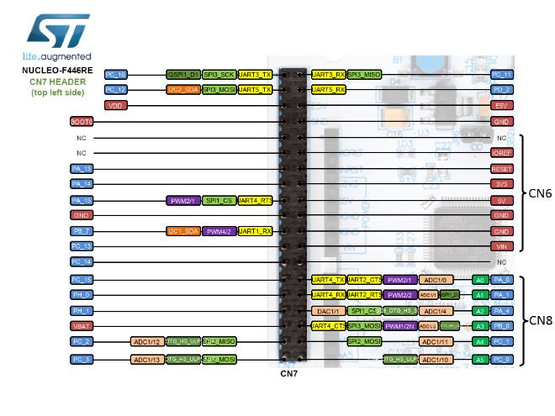

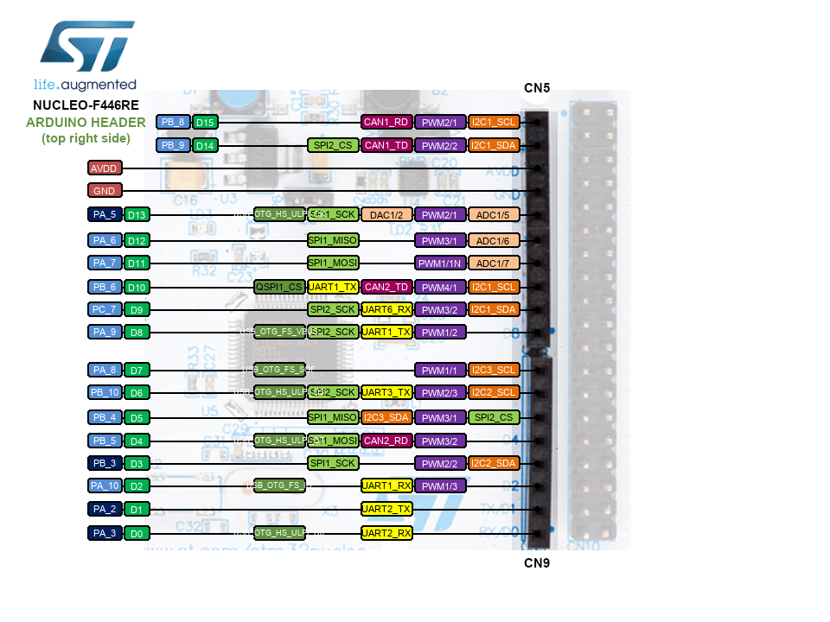

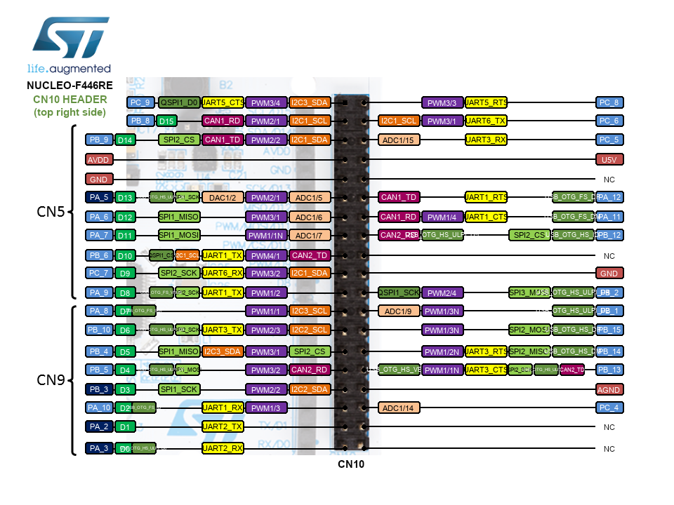

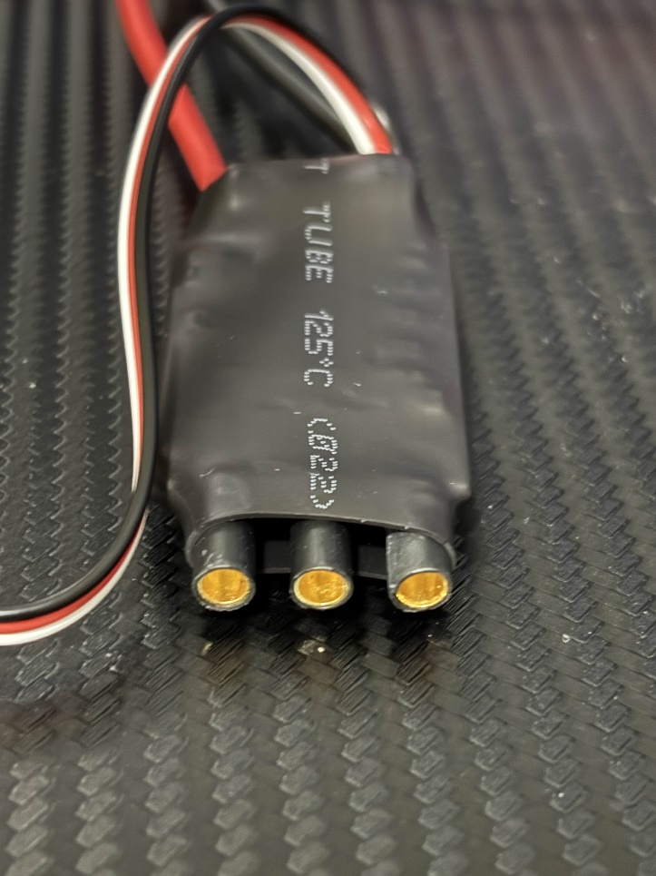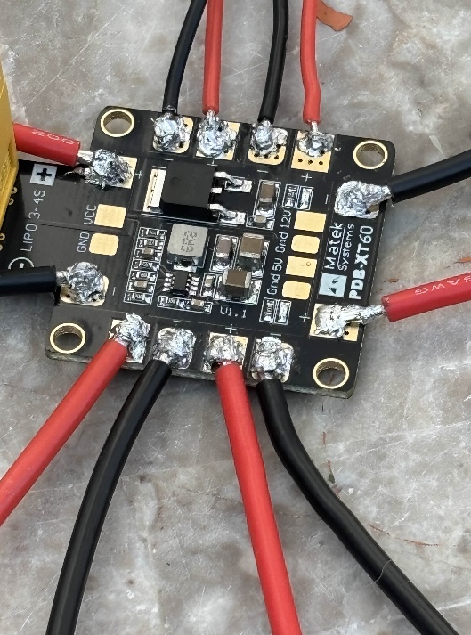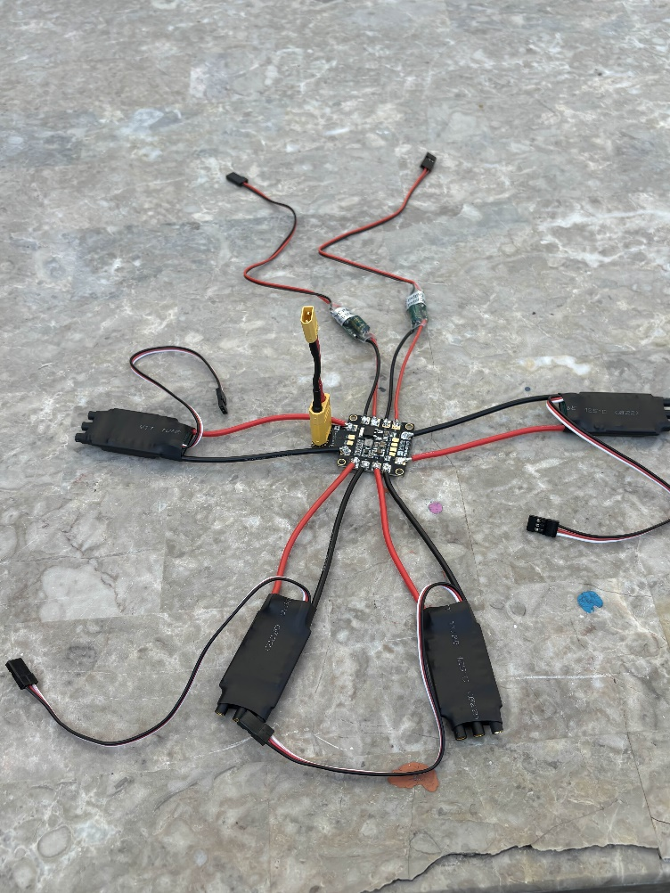The electronic speed controller (ESC) finally got delivered so I decided to solder those onto the PDB which obviously took an hour. Below are images of my horrid soldering (I had to re solder the red wire on the positive pad next to the XT60 connector since it got loose somehow).

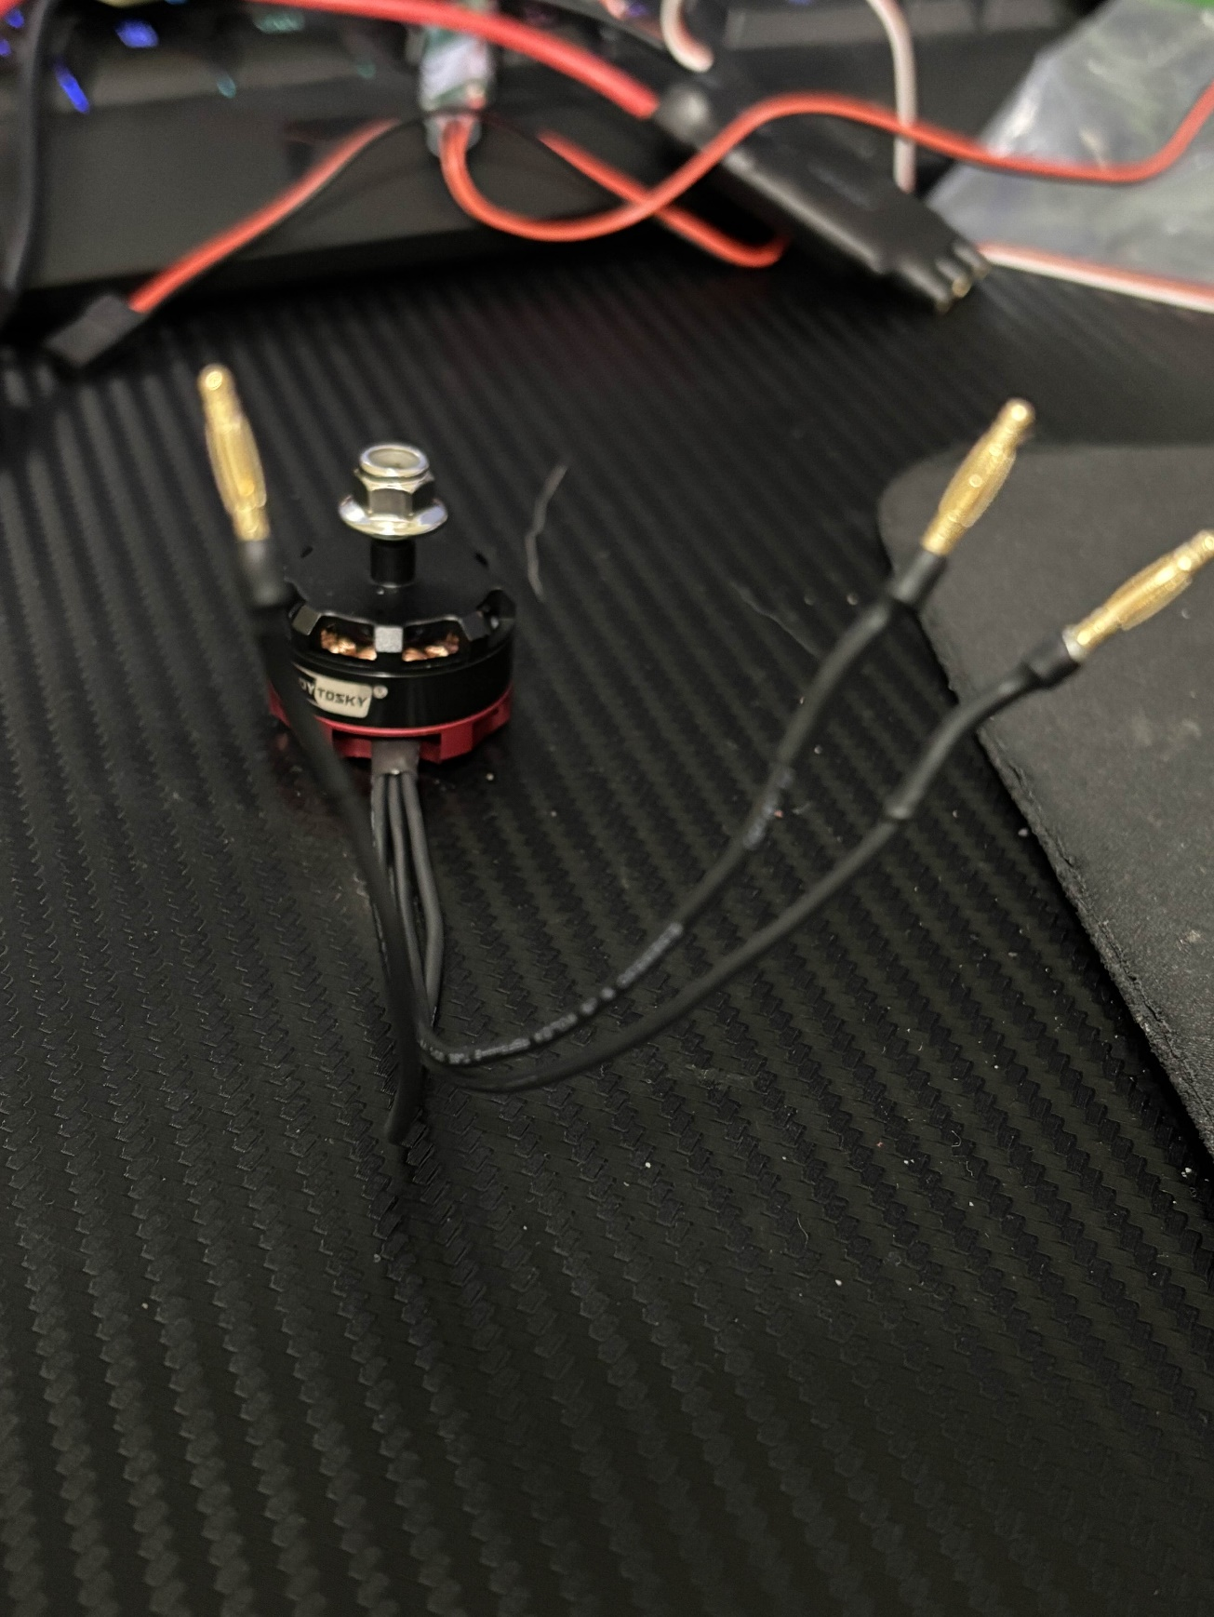So now that this was soldered it was about time I get reminded that I cant read because those ports in the ESC are 3.5mm but the motor plugs are 2mm which it said on the package description and I just couldn’t read. (It did not say how much mm the ESC was but had an image of the ports so I should have known). In the image you can clearly tell those plugs are way too small for the port so I had to return that motor and order some new ones. (Old motors not in parts list since not using for final build). So while I waited for new motors to come in (scheduled for an entire week later) I decided to try to get my STM32 board to communicate with my Raspberry Pi which was actually torture should be a crime to make someone do that. Below is an

image of all the wiring.

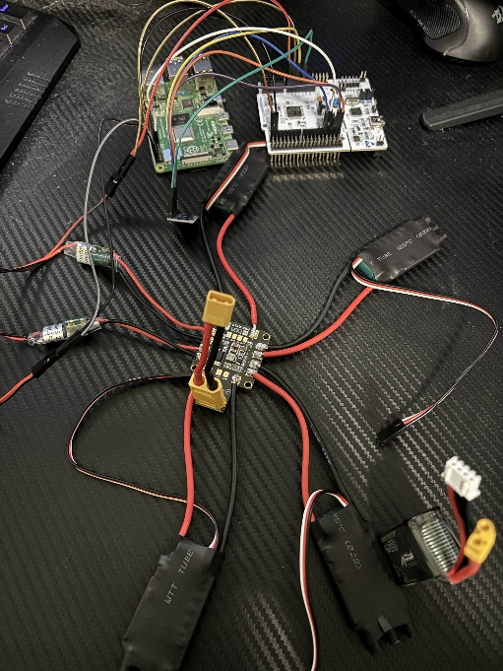

After 10 hours of torture (over 2 days), I finally got the STM32 to communicate with the Raspberry Pi.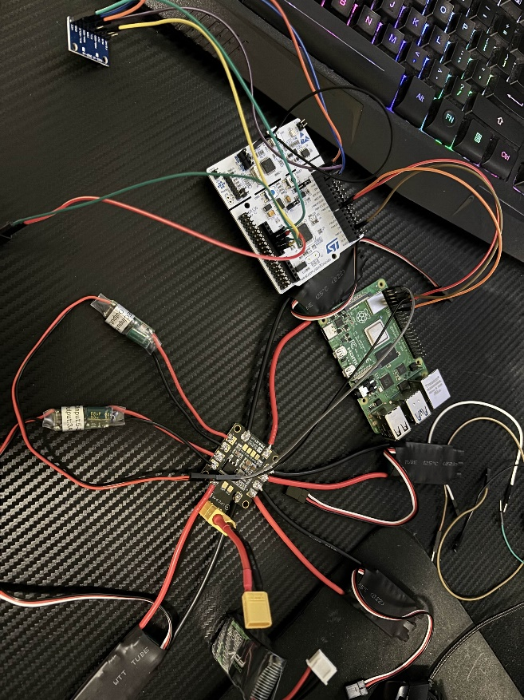 I ran into so many issues trying to get this to work all of which I had no clue what was going on as always.

The image to the left are the wiring and below is my code working (an actual miracle, they should have a national holiday for this event).

So a little background – I am using a program called putty essentially a terminal allowing me to connect via ssh or serial to other devices. I could do this using the windows command prompt but this is just easier. What you see in the background behind the 2 putty terminals is my stm32 program it is called stm32cubeide. That allows me to configure the pinout as well as flash code onto the stm32.

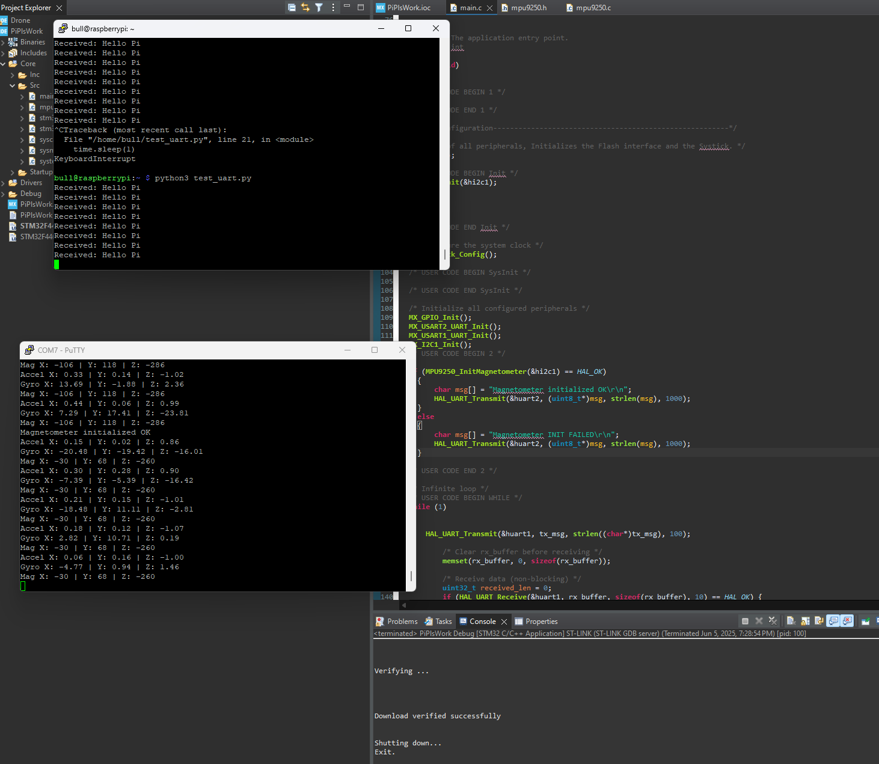

Information:

The second putty terminal is me connecting to the stm32 using serial via my com port through an usb connected from the stm32 to my pc. I need to do this as there is no output available on the stm32cube ide since there is no terminal it can output to. The actual output displayed on the terminal is acceleration, gyroscopic and magnetometer values. The acceleration value is linear acceleration measured in g force unit being g for gravity. This is used to detect tilt as there are x, y, and z values. This can also be used to detect if the drone is falling rapidly without user control and would be used to possibly prevent a crash. The gyroscope measures angular rotation speed unit being degrees per second. This is to determine how fast I am rotating useful for user controls ex to turn 180 degrees and such. The magnetometer measures the magnetic field strength in units microteslas. This is used to get compass heading useful for yaw.

Definitions:

Yaw – turning left or right ex: turning your head left or right

Pitch – tilting forwards or backwards ex: nodding with your head

Roll – tilting left or right ex: bringing your head to your shoulder

Throttle – going up or down ex: ascending or descending

If the acceleration data is 0, 0, -1 that means the drone is sitting flat and still, the negative 1 is simply the drone experience 1g of force downwards due to gravity. This can be used to control pitch and move the drone forwards/backwards. For example, if the Y value reads negative that means the drone is tilting forwards (moving backwards) and we want to stop then we know to reduce power to motors 3 and 4 or increase to 1 and 2.

If the gyroscope data is 0, 0, 1 that means the drone is not rotating much as the value goes up to 131 (at max value it means it would do a full rotation in 1 second) so as of now it would take 131 seconds to rotate 360 degrees. You would use these values combined with the acceleration values to determine direction. For example if the Z value was 60 that means it is rotating clockwise and if there is acceleration that means it is essentially going to be moving in a circle but if the goal was simply to change direction then at a certain degree which would be calculated using the gyroscope data we would have to correct the motors. In our example motors 1 and 4 would have to slow down or 2 and 3 speed up.

The magnetometer values also need to be paired up with the acceleration values for example if you read that there is a tilt in any direction (the drone is moving in that direction) then based on what you want to do (ex: stop the drone you can adjust motor speeds based on acceleration values). Lets do an example with all 3 components on next page.

**Gyroscope (angular velocity)**

| **Axis** | **Value** | **Meaning** |
| --- | --- | --- |
| X | +15°/s | Rolling to the **right** |
| Y | -10°/s | Pitching **forward** |
| Z | +20°/s | Yawing (turning) **clockwise (CW)** |

This tells us the **drone is rotating** in three directions:

* **Rightward roll**
* **Forward pitch**
* **Turning CW**

**Accelerometer (linear acceleration and tilt)**

| **Axis** | **Value** | **Meaning** |
| --- | --- | --- |
| X | +0.2 g | Slight tilt to the **right** |
| Y | -0.4 g | Tilt **forward** (moving forward) |
| Z | +0.8 g | Less than 1g = **slightly falling** |

This shows:

* Drone is **tilted forward-right** (combination of X and Y)
* It is **not holding altitude well** (Z is below 1g so descending)

**Magnetometer (compass heading)**

| **Axis** | **Value (µT)** | **Meaning** |
| --- | --- | --- |
| X | 10 | Magnetic east |
| Y | 35 | Magnetic north |
| Z | -5 | Slight downward magnetic component |

You would compute heading from this using math:

Heading = atan2(Y, X) = atan2(35, 10) ≈ 74 degrees.

Combining everything:

* **Gyro:** The drone is rotating (rolling, pitching, yawing)
* **Accel:** The drone is tilted forward-right and falling slightly
* **Magnetometer:** The drone’s forward direction is northeast

**To stabilize the drone (hover in place):**

1. **Roll Correction** (stop right roll):
   * Reduce left motors (M1, M3)
   * Increase right motors (M2, M4)
2. **Pitch Correction** (stop forward pitch):
   * Reduce rear motors (M3, M4)
   * Increase front motors (M1, M2)
3. **Yaw Correction** (stop turning clockwise):
   * Reduce clockwise motors (M1, M4)
   * Increase counter-clockwise motors (M2, M3)
4. **Throttle Correction** (stop descent):
   * Increase speed on **all four motors** slightly to get back to 1.0g on Z

This part was very easy to code but a bit harder to understand values, however, it didn’t take more than 30 minutes to get everything working.

Now onto the 1st terminal as seen in the image a few pages ago. The connection to the pi from the stm32 however took forever. The output in the first terminal is very simple just says “Hello Pi” however behind that is 10 hours of pure pain. To get the stm32 and pi to communicate UART was used the TX/RX ports on the pi and stm32 connected TX to RX and RX to TX and also GND to GND. In the wiring diagram presented a few pages back on the pi ports 8. 9. And 10 were used. On stm32 the PA_10 and PA_9 ports under CN10 (very last diagram) were used. The wiring was very simple however the problems I ran into were not (well maybe they were but I was too braindead at the time). Anyways I can complain for years but the main issues were power, mysterious red led blinking (it still does, I don’t know why), code not working for the millionth time, wires breaking, shorting the battery, and breaking basically everything.

At this point most of the physical stuff was done I had connected all the wires and communication worked out so it was time to code stuff the following images show everything that went wrong. Each image is about an hour spent.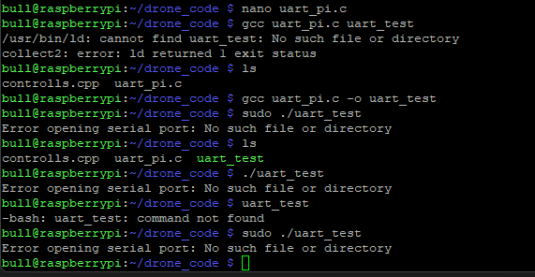

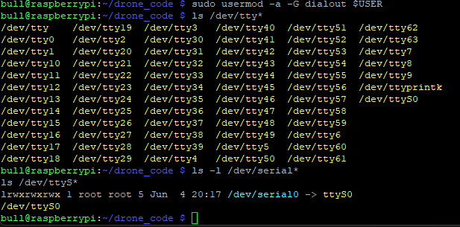So this was me trying to communicate with the STM32 and Pi, which I previously said worked but as all my code randomly stopped working causing another 12 hours of work to be dome. In the image above nothing wants to run for some reason also there it also says error opening the serial port essentially the port my pi is using to communicate with the stm32 is in use which is exactly what is supposed to happen as I am using it to communicate but nope it doesn’t understand that.

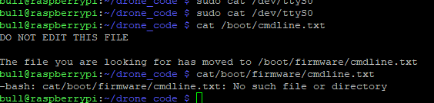The image in the last page simply shows a list of all the ports and my frustration that the one port for communication isn’t working.

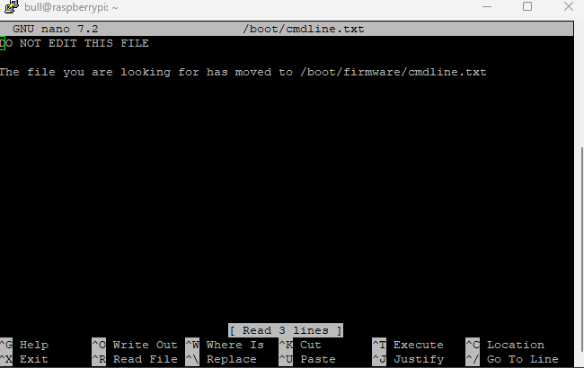This is me trying to find the main file it redirects me to another directory saying the file is there but obviously when I try to go to that directory it doesn't exist because why should it.

And this is me accessing the file after a minute of struggle and it says the exact same thing wonderful.

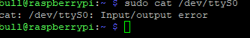

This is me testing the same thing again hoping it would have a different result, speaking of do you know the definition of insanity?

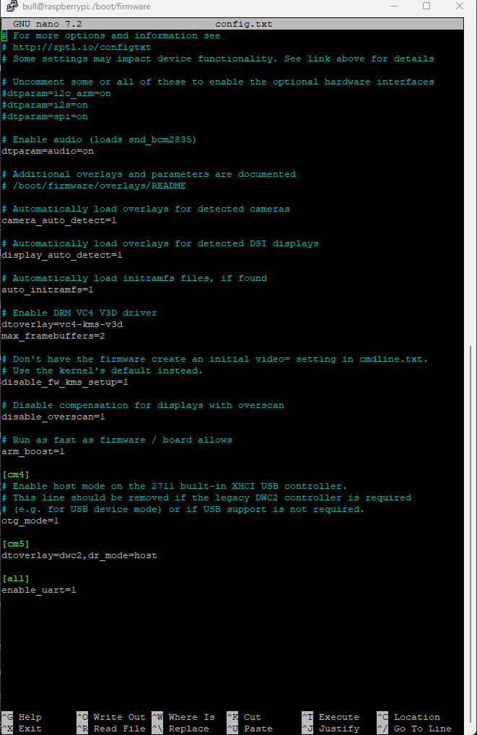

In this image I finally accessed the file after completely rebooting my raspberry pi, I then disabled Bluetooth on the pi so that the one port I need would be free and I am not using Bluetooth anyways.

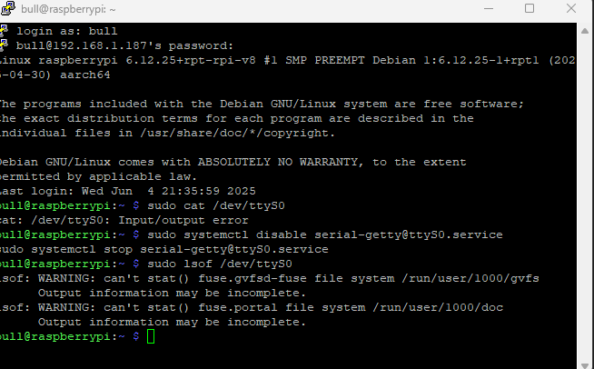

So after the fix it still didn’t want to work and this is because I am using the wrong port which I found out eventually.

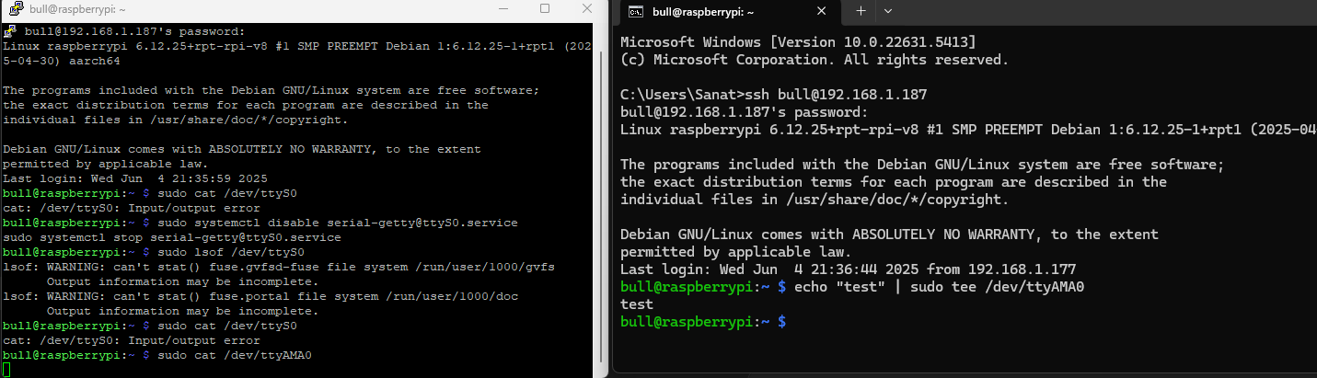

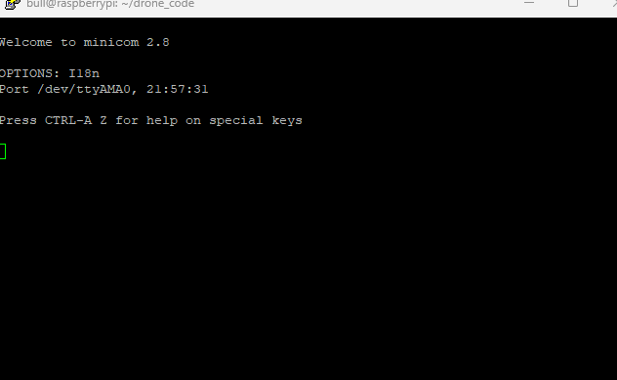This is me using the right port for communicating over to my stm32 /dev/ttyAMA0 but not the right port to test pi to pi communication which is what im trying to do in the second terminal.

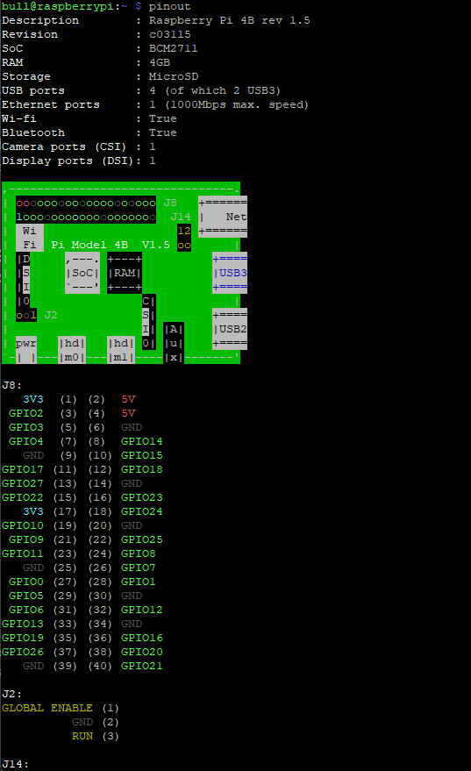Image in the last page is me downloading and using Mincom since I googled and this was a solution obviously does not work so that was another hour wasted.

This image is me looking at the raspberry pi’s pinout within the terminal which I did not know was a thing so this was pretty cool at least for me. Nothing went wrong here just something nice for once.

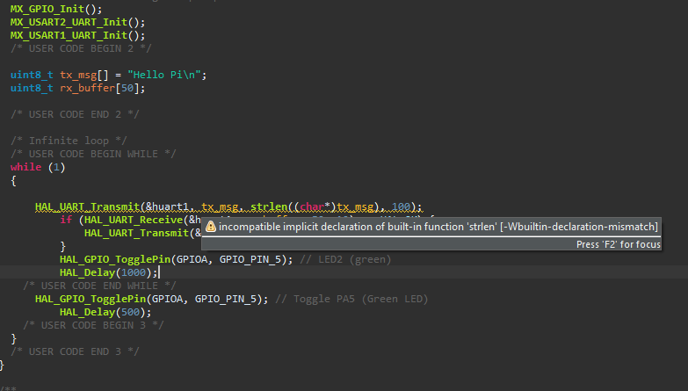

This is me screenshotting my error message to look up since I have no clue what it means. I later found out that it means that I was missing a library which I did not include.



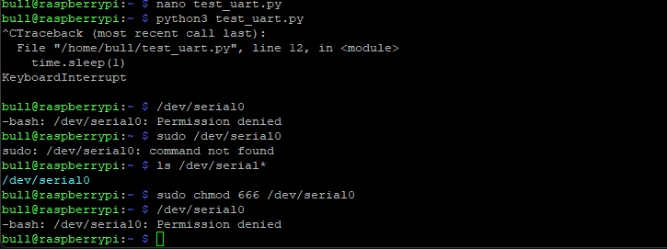Back to the pi, I had to redownload the os onto the sd card again since I broke something I don’t even know how this time. But when I tried to upgrade it just did not want to work even though it did the last 20 times.

So I tried using a different port for testing the communication and apparently I don’t have permission to access it on my own raspberry pi that I own and bought which is just wonderful.

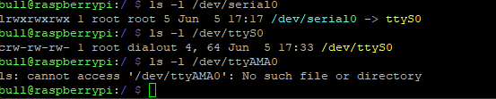

Insanity

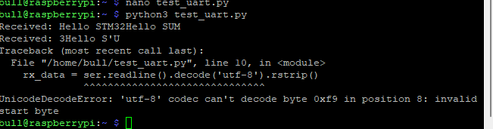

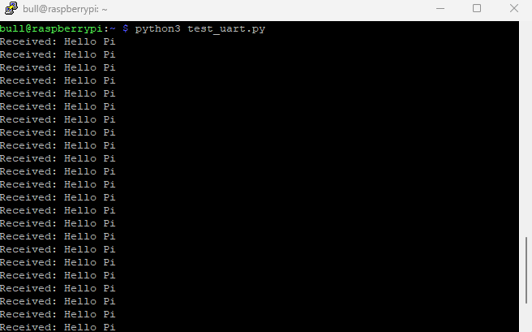Error in my raspberry pi code this time I need to google.

I am successful in receiving data as before but obviously not in sending data.

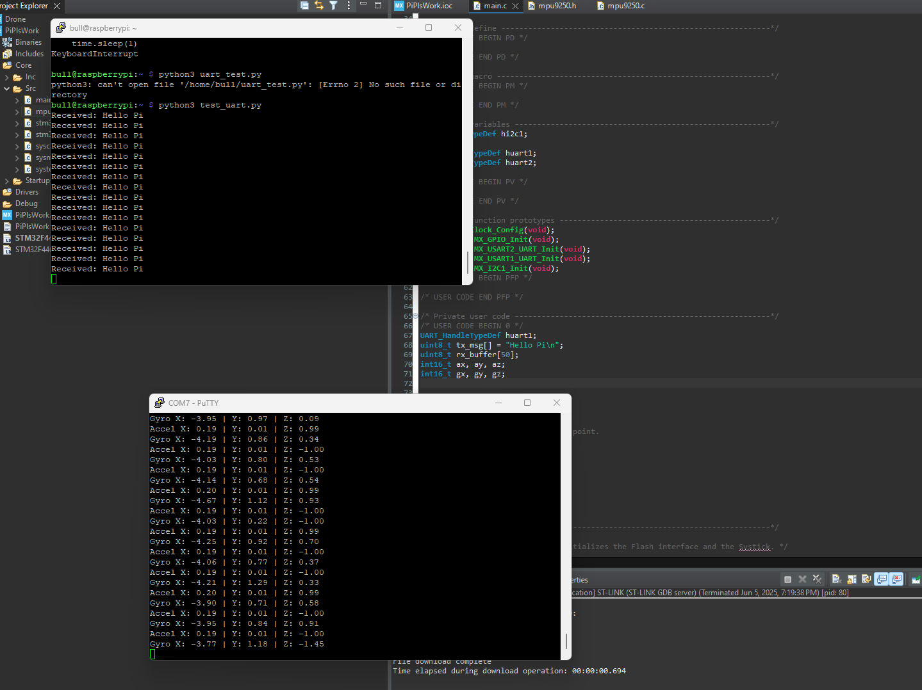

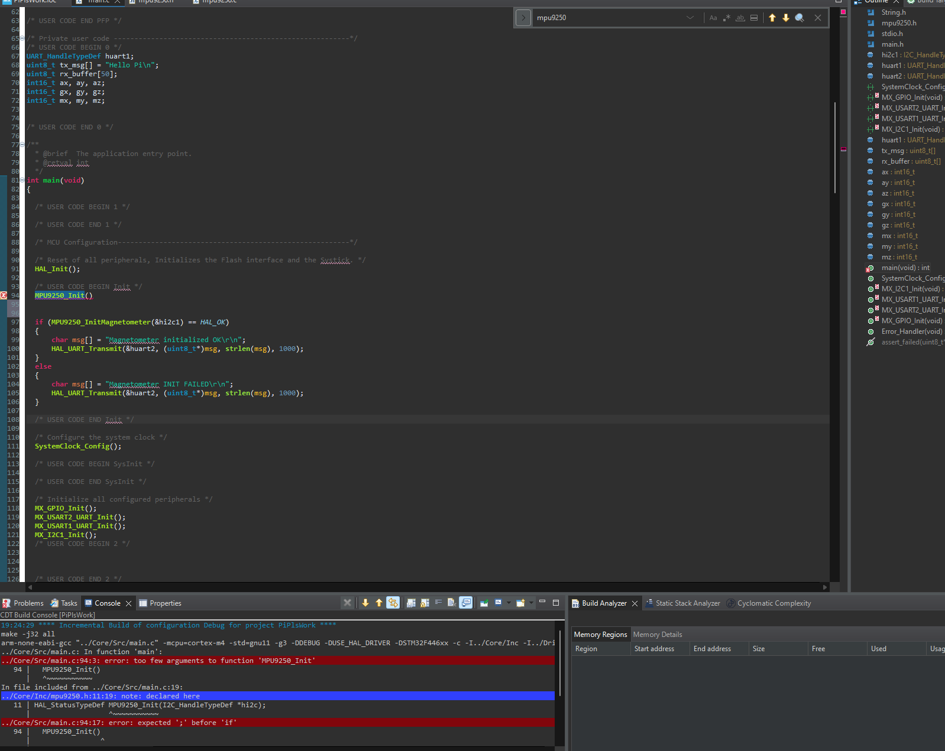This was just me testing to make sure I didn’t break the mpu9250 from sending data while messing with everything else and it surprisingly works with receiving data on the pi from stm32.

More errors present in the last image. It was just me redeclaring stuff which is a big no no.

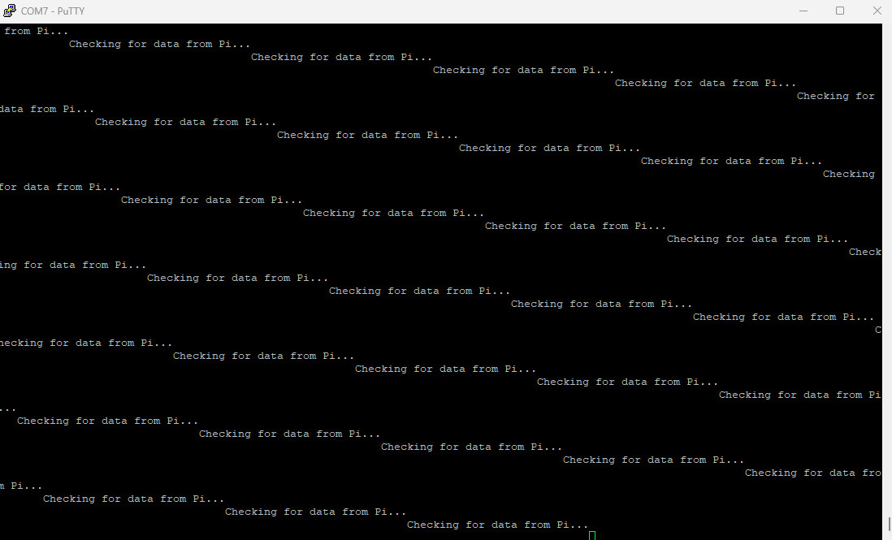

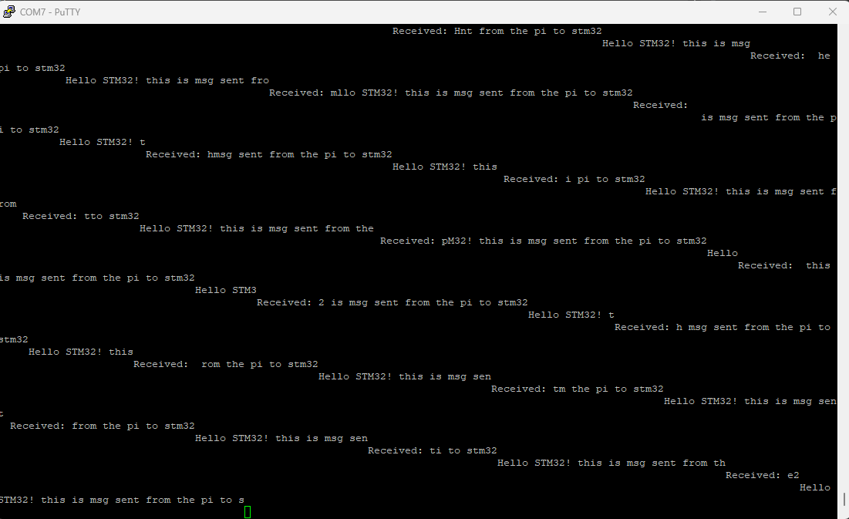It broke and I still do not know what happened there to this day.

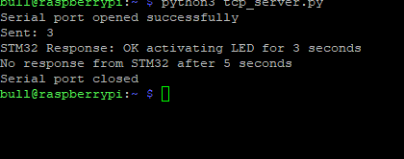The last image is titled “progress” by Sanat Sachdev. This was the first real progress made that day and it was me receiving jumbled input from the raspberry pi and printing it to my serial monitor from my stm32.

So I thought maybe the problem is in the actual printing of the data since I am receiving something so instead I tried to turn on a light from my pi to stm32 basically I send code from the pi which is just a number and my stm32 takes that number and turns on the light for the x amount of seconds and this did work despite what it might say on the image above. That is there since the stm32 replied back which is also seen in the image but my pi code kept on checking for another response which was never going to happen.

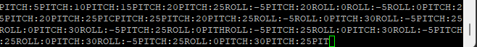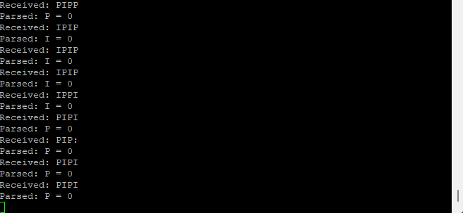

So this image is even more progress I am receiving stuff from my pc somewhat and also somewhat sending it to the stm32.

Before moving on to the rest of the failures I should elaborate on my goal for this part of the drone. As mentioned like 20 pages ago the raspberry pi is meant to communicate with the pc. Now the stm32 can also communicate with outside sources but those are either by direct connection like a wire or a radio frequency emitted by a controller and those are more expensive then raspberry pi’s so we go for the harder route. (When we get to the motors this part will make a lot more sense). So to communicate with the raspberry pi from my pc it is easy. All I have to do is connect over Wi-Fi and ssh which is a communication protocol already set in place used by your computer and mine and everyone in the world occasionally at least. Think of ssh as simply a way of communicating over a wireless network. To connect to my pi I did ssh pi@” my pi’s ip address” which was another hassle to get as I mentioned before. Anyways, the purpose of communication from pc to pi was to send commands to my stm32 over wired network the uart ports commands like pitch or roll or throttle and more. Really quick code breakdown since that stuff is so boring:

I connect to my raspberry pi from my computer by running a python script which basically searches for an open socket using the pi’s ip address and port 8000. For example my raspberry pi’s ip address is 192.168.1.187, this is a local ip address only works if you are connected to the same wifi network, this is pretty easy to get on the same wifi network basically public information, there are apps that let you get this or in device settings or router settings you can find it. There are also global ip addresses that is how you connect to websites when you are typing in something like youtube.com that is just the domain name and through a system called DNS you can connect to the server but in reality a server stores all domain names to ip addresses, behind all the interface really you connect to you tubes ip address just instead of having to type a bunch of numbers you just type the word and it gets translated through dns. Now for ports, those are like doorways different things use different ports for example port 443 is most likely what you will use to access sites on the internet as port 443 is meant for tcp https connections if you want to know what that means google it as it is unrelated to this. Ports are numbers between 0 and 65535, 8000 is a port mostly used for custom stuff in my case connecting to my pi. Now that we know how to transfer input what am I actually sending over to my pi? Well I send 4 character outputs the first 1 or 2 reserved for the command ex P for pitch and the last 2/3 for number ex 05 or -10. These numbers are then used by the pi to increase or decrease motor power based on a percentage system. The max for pitch and roll and stuff is 30 degrees. And max throttle is 2000, this is 100% power, and 1000 is 0% or off it could really be any number but it is just based on the pulse sent from the stm32 to my esc and so 1500 would be 50% power.

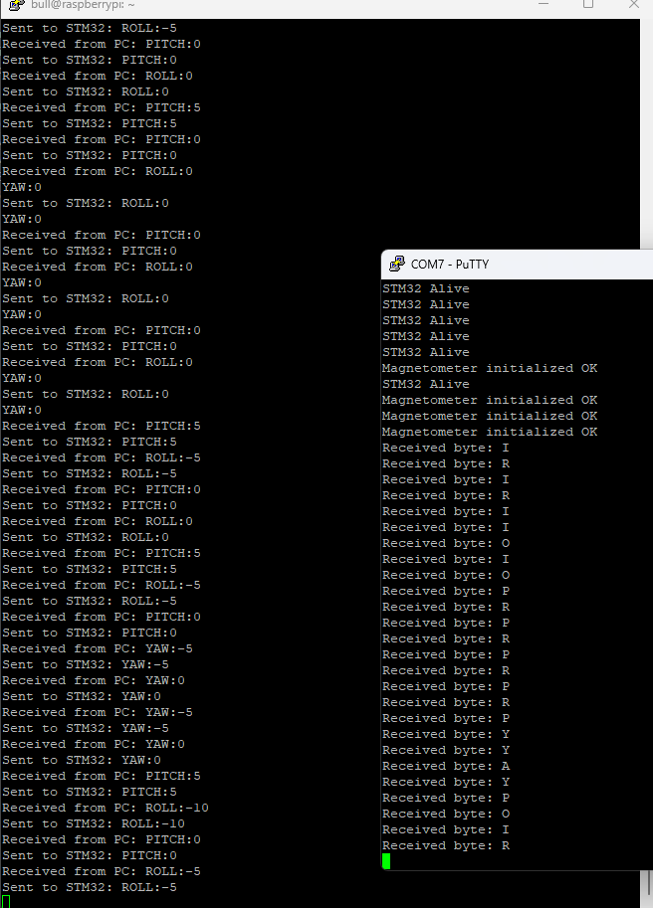Back to stuff that went wrong. In this one it was doing one letter at a time.

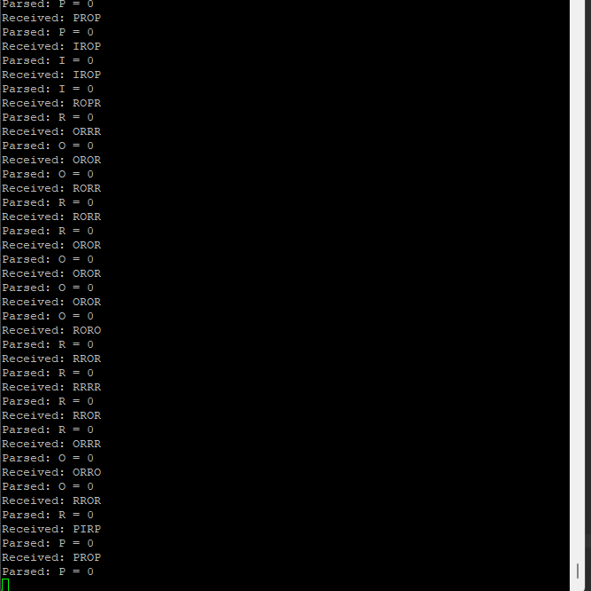

Once again receiving jumbled commands there are no numbers in there for some reason also for future reference if the title says COM7 that is what my stm32 is printing out and if it says bull@raspberry that is what my raspberry pi is printing out. If I cropped that out of the image then if it says anything about receiving from pc it is the raspberry pi.

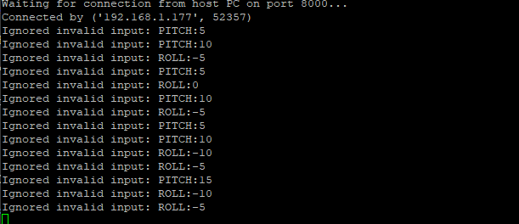

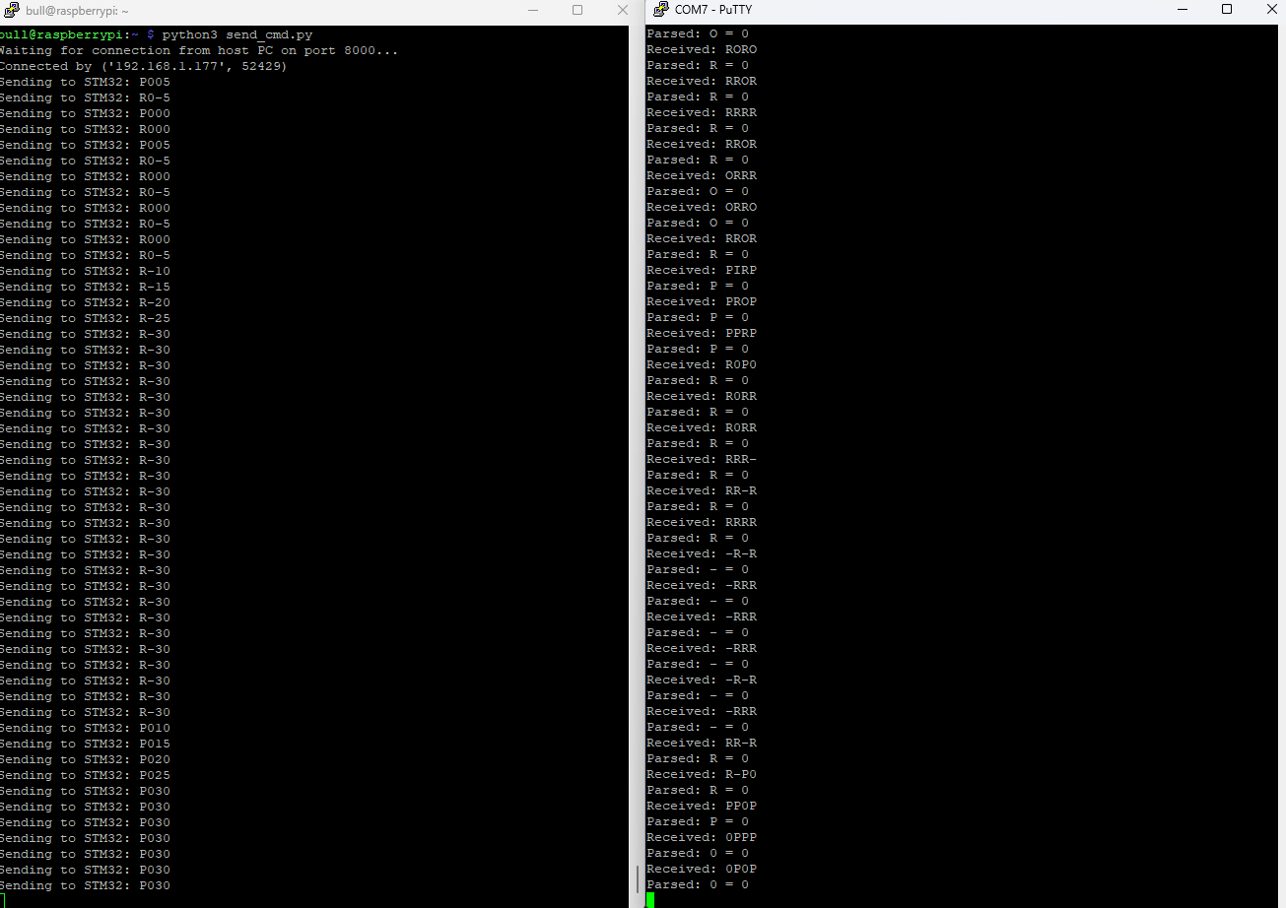So in that last image on the previous page was me sending the wrong commands to pc as I decided to change my system so I could see what was going on but sent the wrong wording on accident as it needs to be very precise it didn’t work.

More of same stuff as before jumbled commands but a little bit better still no numbers tho.

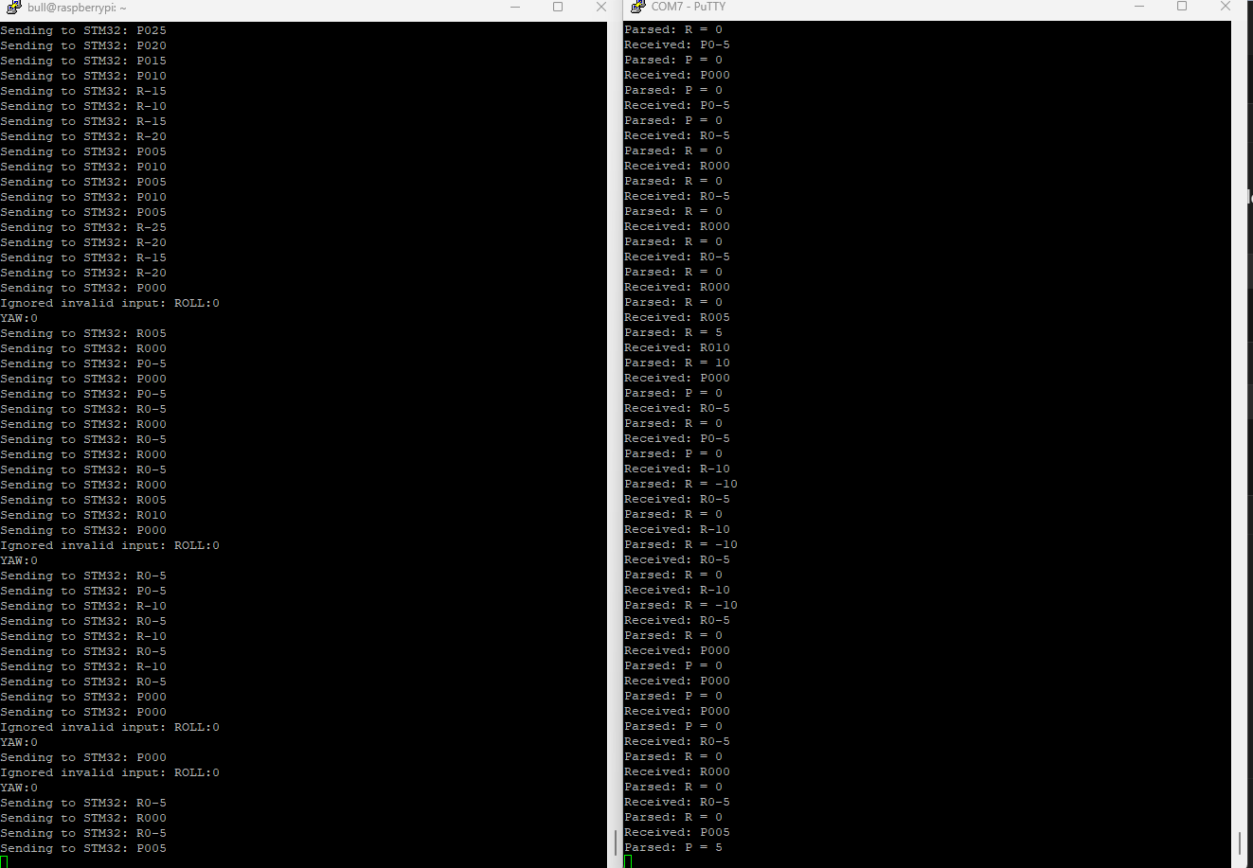

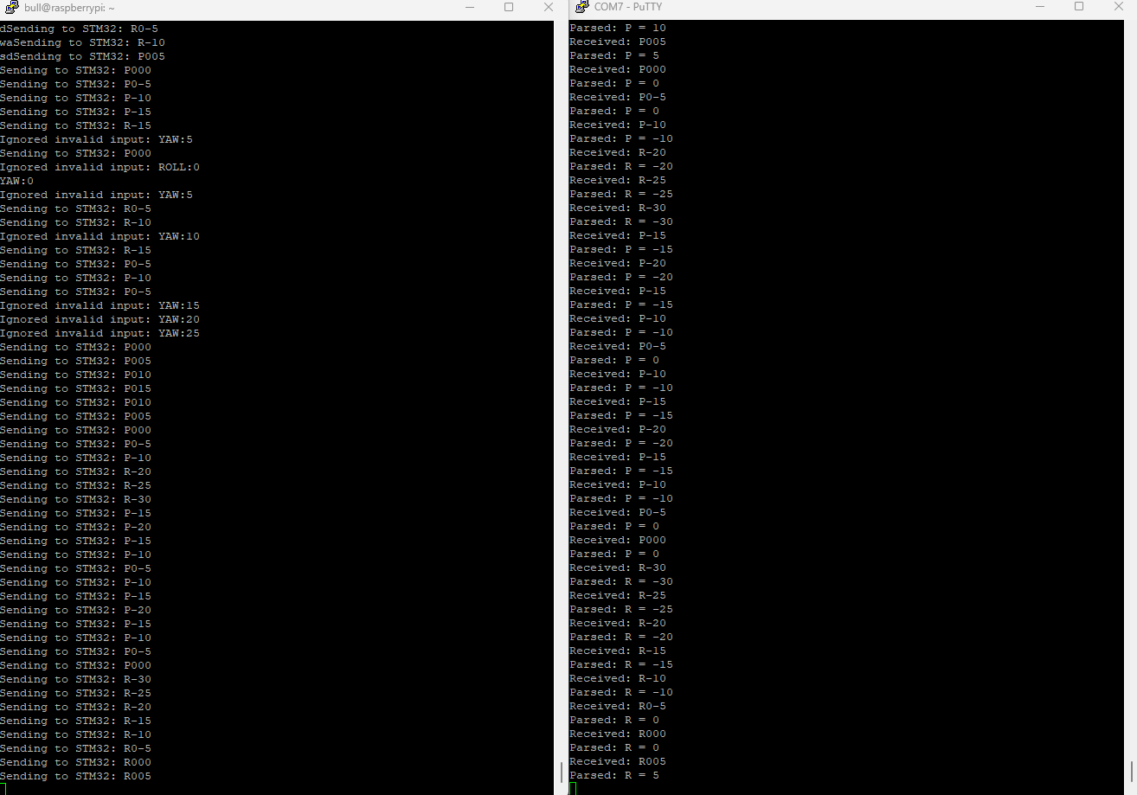It works absolute Christmas miracle this caused for an entire 2 minutes of celebration before my pc forcefully shut it self-down since that was too much success and I obviously can’t have that. I still do not know why it crashed; it doesn’t when I run the script now. Im pretty sure it was because I got too happy. Also the negative 5 wasn’t working due to parsing errors you can see in the image it read -5 as 0 which I attempted to fix.

In this there was some issues with the yaw and the -5 still was not working so I gave up.

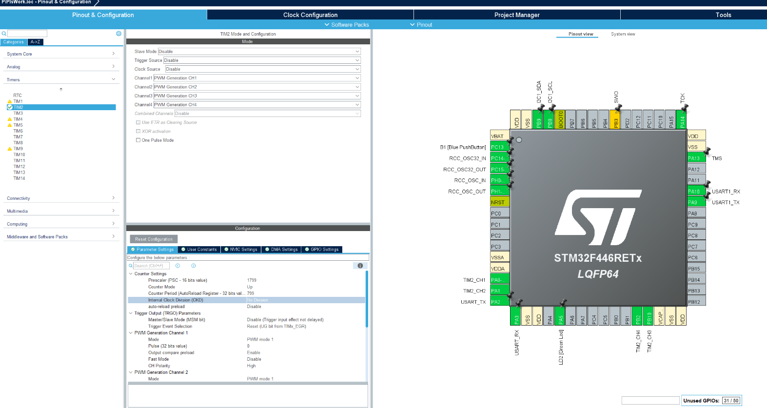So now it was time to do the motors and esc as the code was mostly working. This is what the ioc for my stm32 looks like, on this screen I can configure what different pins do and more. In the window on the left (in the image) you can see stuff such as baud rate channel numbers and more.

There is a lot going on there but its really simple. On the right is simply the pin configuration but on the left the top window is the channels, each channel is set to a different pin which is then connected to an esc that connects to a motor ch1 goes to motor 1 (top left).

Baud rate applies to uart communication from the stm32 to the esc’s, it simply defines how fast bits are sent over serial ex 115200 is 115,200 bits per second this is not on the image above but is essential for communication between pi, stm32 and pc.

PSC also called prescaler is a register in the stm32 timer that divides the clocks frequency basically allowing you to work with real time milliseconds, microseconds etc. We need this to slow down the stm32’s clock because that runs very fast even though it is a small device it can still count from 0 to 72 million in a second now that is nothing compared to a modern pc but it is still very fast for something like a motor.

Before getting to know the rest of the motor and esc you must know what a pwm is. Pwm or a pulse width modulation is how we control motors through the esc. The stm32 generates a wave, the period is how long a full cycle last ex 50hz or 20ms, and the width is how long the wave is on ex in our case 1500 would be half of the wave thus 50% motor power and 2000 would be the entire wave. Frequency is 1/period can be calculated. Now the pulse width is what determines the amount of time wave is on meaning how much power motor is at in percent so that is what is sent from the stm32 to the esc. Now the esc expects to get pulses every 50hz to 400hz and as defined previously the prescaler divides the amount of operations per second to get into real time in our case in the image it is 1799 and using the formula psc = frequency of clock / frequency of timer we can calculate real time. Ex 1799 = 72,000,000 / x so 72,000,000/1799+1 = 40,022hz roughly 40khz about a tick every 25 microseconds. Now the period is how long it takes to count up to the arr value so 40k. You can calculate this by doing 40,000/799+1 which is exactly 50hz meaning the frequency of the pwm signal is within bounds for the esc. Now that we have the timing right we can send pulses to the esc in order to change motor speeds.

But before testing motors we have to configure the esc as nothing is every easy or simple. Now remember how I am using a raspberry pi instead of a controller well the instruction manual was intended for someone using a controller and so I went to sleep after being unable to do anything. 2 days later I decided to try again and after hours of frustration since the timing wasn’t working. I essentially had to send a constant 2000 pulse signal to the esc before plugging it in but since I do not have a controller that is virtually impossible because I can not have my stm32 board plugged in at the same time since the gnd would not be recognized since the stm32 board and esc don’t mix well. Now after hours of trying stuff nothing worked (I actually somehow configured the first esc on accident when trying to get it to connect and other troubleshooting but I still do not know how). So I got an old Arduino board I have and with my genius I decided to manually send the signals instead of relying on the computer. This time I will show my code since it is brilliant and I was so proud of it when I made it but am now realizing it is so simple and I should have probably thought of it sooner. I left comments for a line by line explanation.

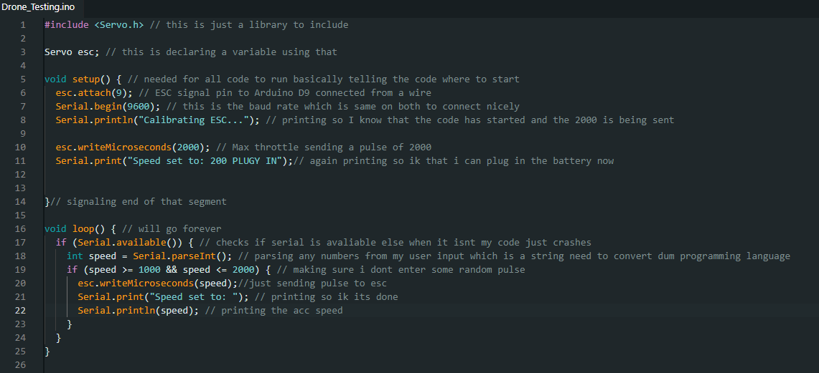

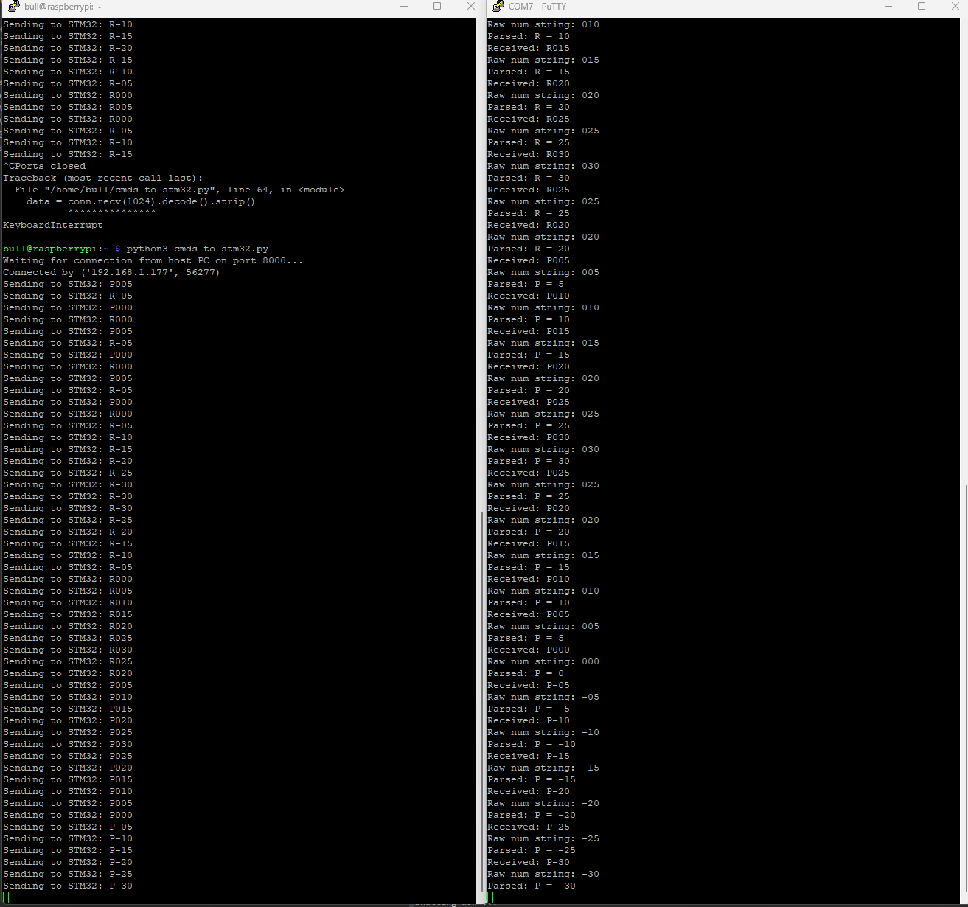Anyways, I used my Arduino and my pdb and the Arduino would constantly send 2000 and then within 2 seconds of me plugging in the battery to the pdb and powering on the esc I have to type 1000 and my code will send a 1000 pulse then the esc makes happy noises (beeps) and it is configured. I also fixed the -5 finally. I also added a throttle input gooes up by 5% of 50 every time and also here is the manual for the esc.

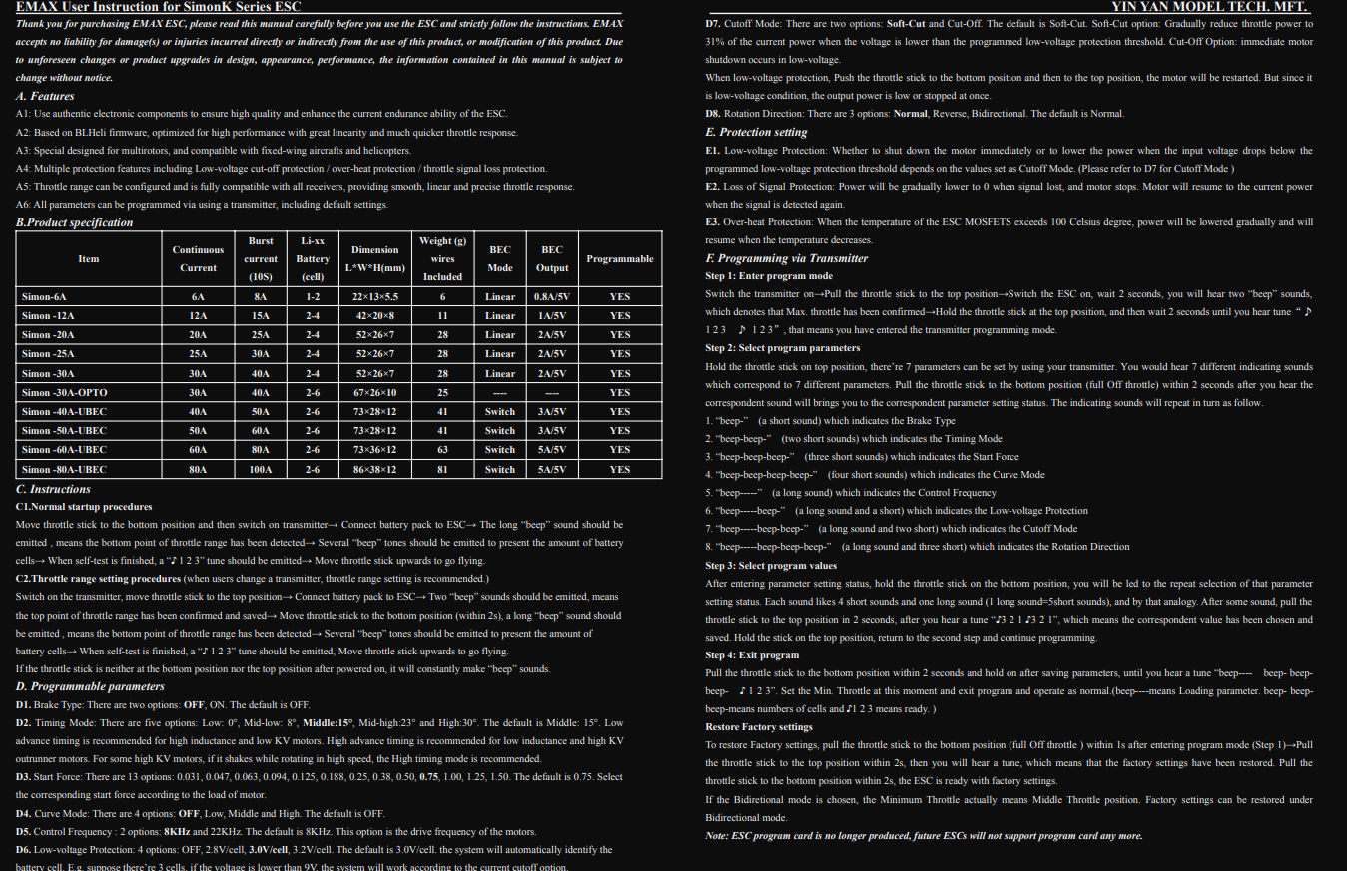

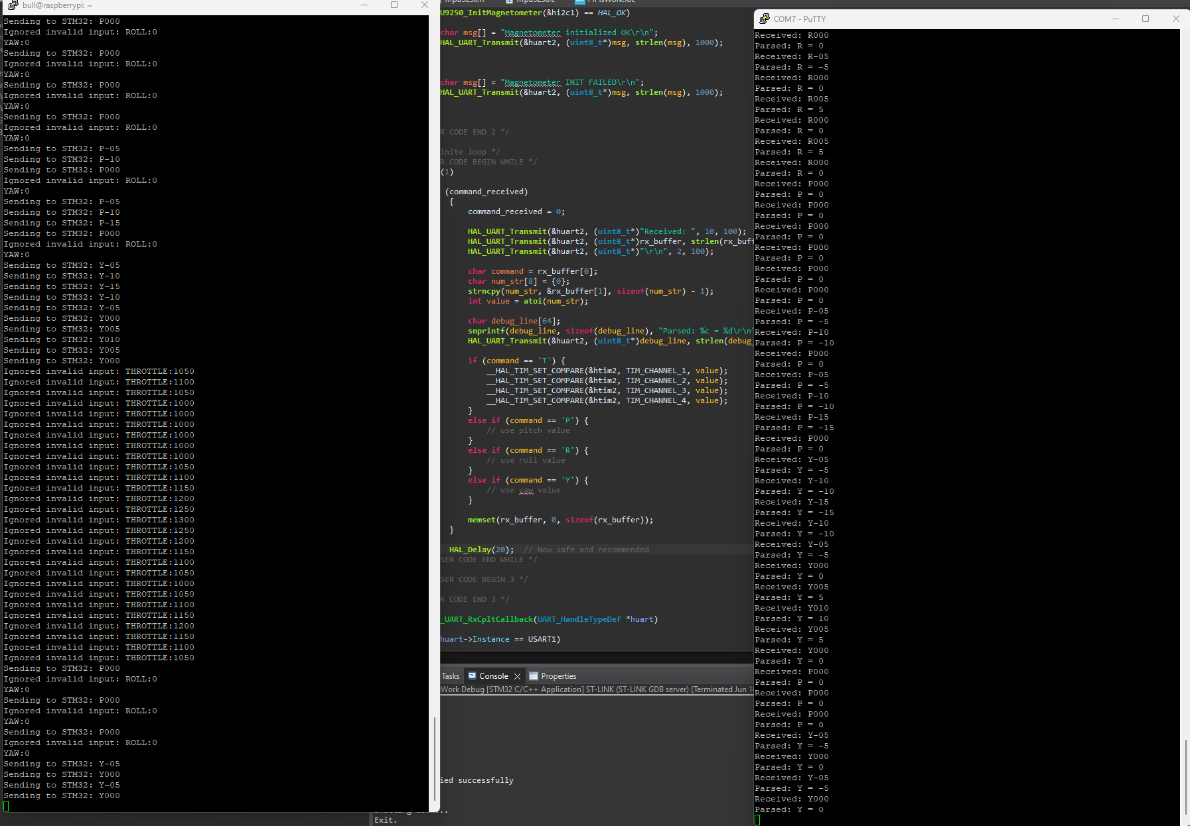

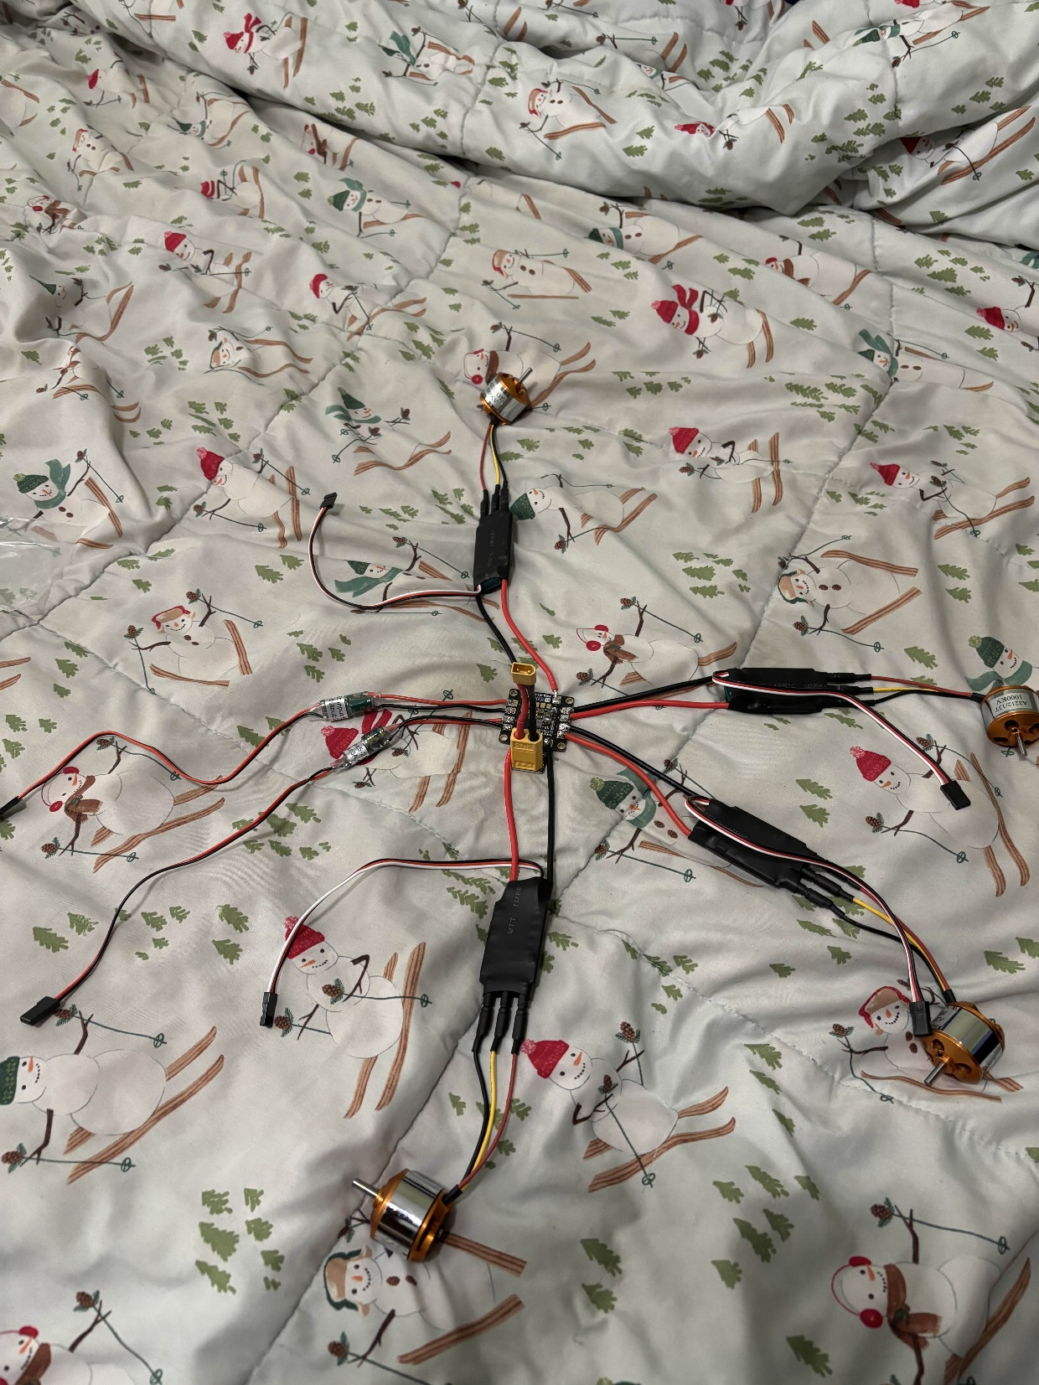Now that all the code was working I tested a motor and it was so incredibly fast that I cut my hand, at least when I say I put blood sweat and tears into making this drone I’m not lying. But because it was all working I needed a temporary frame so to cardboard I went.

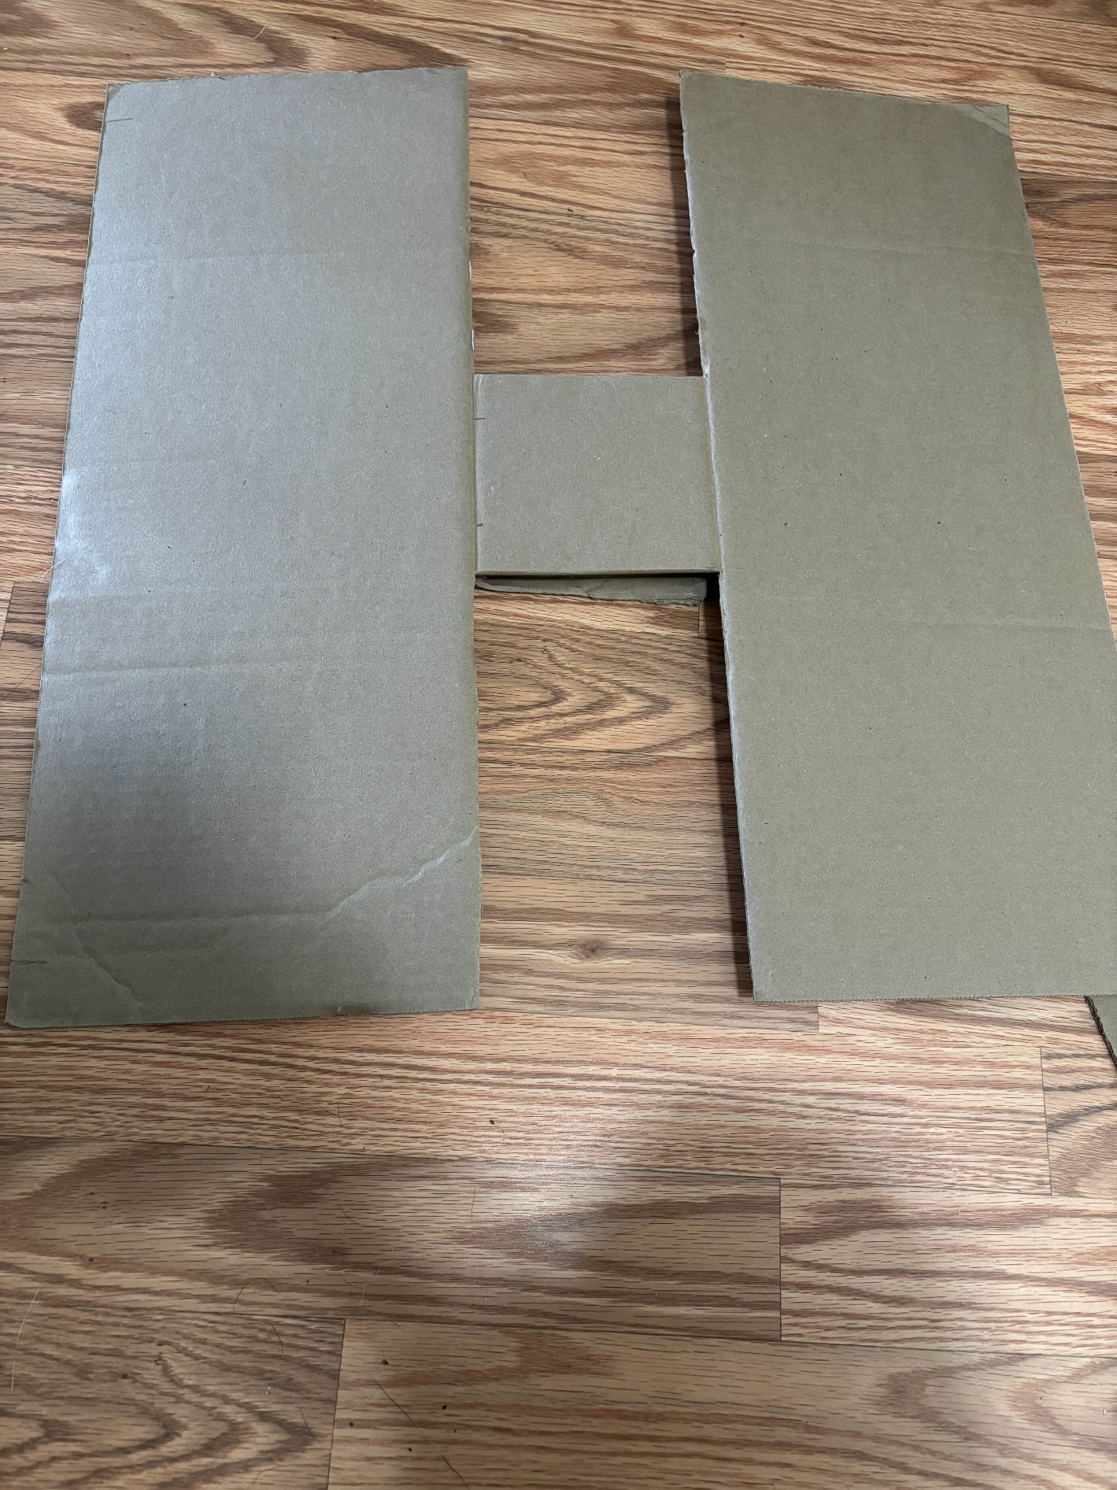The image in the previous page shows the entire drone layout without the boards (pi and stm32). So as this is a quadcopter and I needed a center for the board I began on a simple design.

Obviously didn’t work nothing I do first try does so I decided to make the arms and body separate. I eyeballed some measurements since it was like 1am and I was too tired for this and just layered a lot of cardboard and covered it in electrical tape. Then I did the same but for square cardboard pieces for the middle and then taped it all together using electrical tape. Now I don’t know if it is because I was sleep deprived but I forgot I had 2 4x4 inch boards to put on my drone because I left no room for that thus another piece of cardboard was attached to one side, also at this point I ran out of electrical tape so we had to ration that. The following image is the final design.

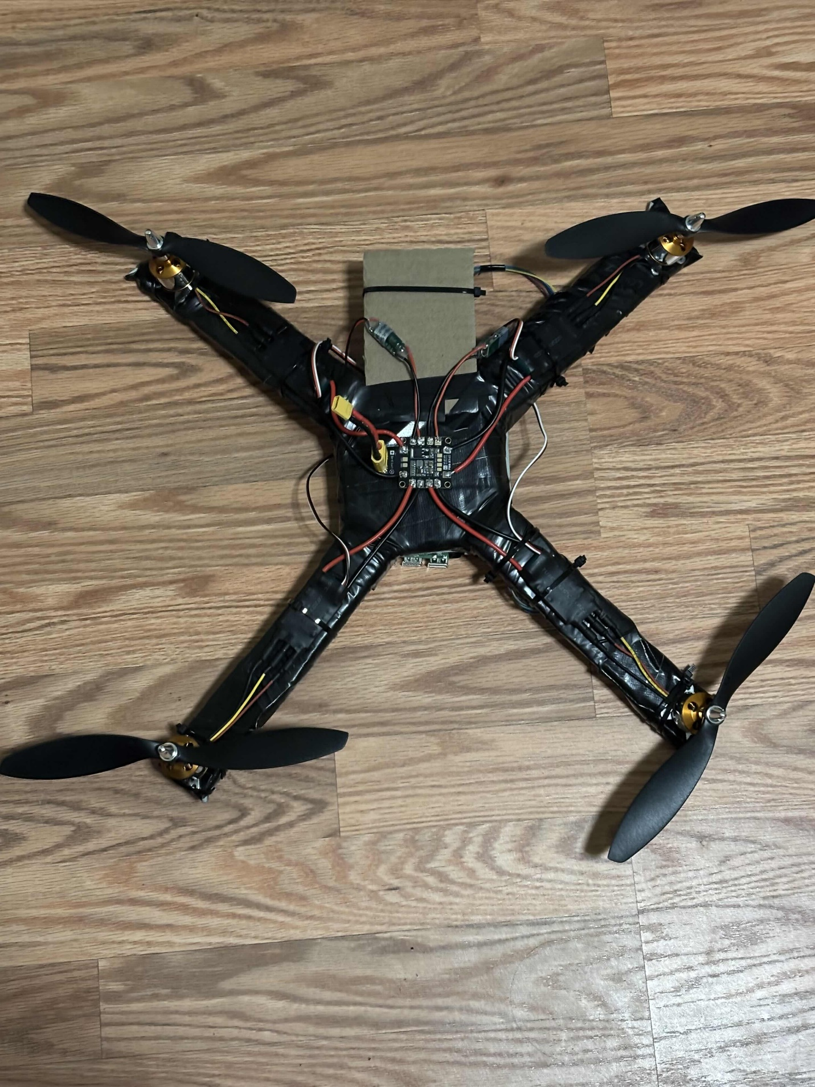

Now if it looks uneven, it’s because it is. The arms also are higher or lower then the rest which makes it unable to fly at all.

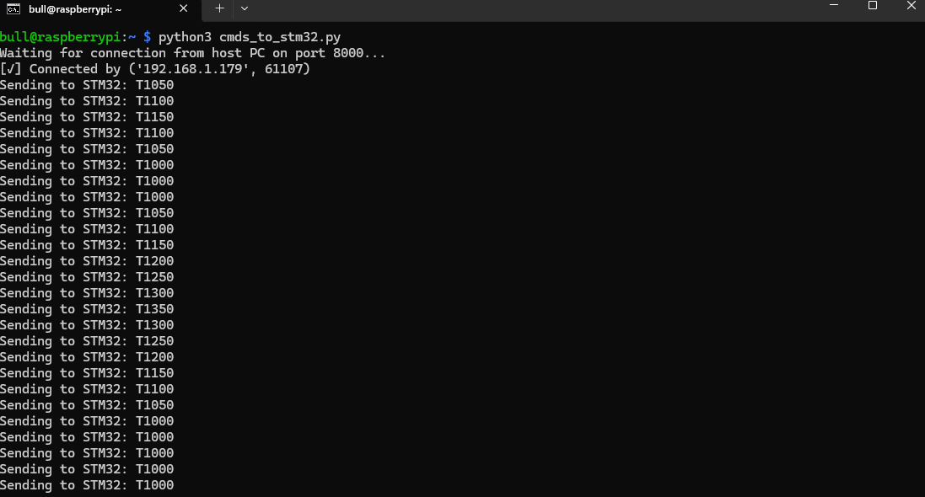Side Note: It did fly for about a few seconds before crashing when I first tested it while the arms were a bit more even but im pretty sure the crash caused it to deform and now it wont lift off the ground. This is because of physics.

Image of software during test:

Link of test: https://youtube.com/shorts/KvLbtWVPS-w

Calculations:

|  |  |
| --- | --- |
| Mass mmm | 0.500 kg (500 g) |
| Battery Voltage | 11.1 V (3S LiPo) |
| Propeller Size | 9x4.7 inches |
| Total Motors | 4 |

Force of gravity acting downwards on the drone:

Fg = 0.500*9.8 = 4.9 N

To counter thrust must also be 4.9N or greater resulting in 1.226N per motor.

Since it is a quad copter with 4 motors each motor has to apply 1.23 N of thrust to allow it to hover in the air any more and it will move up in the y direction lower it slowly to descend safely and land.

Estimated power required to hover:

At hover it would have a small velocity like 0.5m/s so we can use the formula P = F*v to find power: P = 4.905 * 0.5 = 2.45 W, this is how much you need to oppose gravity rest is used for heat and drag.

Example thrust when going up assume you want to go up at 2m/s:

T = m(a) ~ 0.5*(9.8+2) = 5.905 N / 4 ~ 1.5N per propeller

Work done to get drone to 1.5m:

W = mgh = 0.5*9.8*1.5 = 7.36 J

Kinetic energy at 3m/s

KE = 1/2mv2 = ½ *0.5 * 32 = 2.25J

As previously mentioned and as seen in the video the drone doesn’t hover though and this is because of torque and bad COM mostly caused by the frame and the positioning of the boards on the drone.

Torque calculation:

T = rf sin()

My one drone arm is 9.6 inches or 0.24 meters, and none of the arms are even in terms of angle especially 2 arms which are much lower than the other 2 which causes a torque and that means it tilts. Lets assume that the 2 arms are at an angle of 20 degrees lower than the other 2. First we must calculate the X and Y components of the lift.

T = T cos/sin ()

T = T * cos(20) = 1.15N

T = T* sin(20) = 0.420N

This means there is 0.076N less force and a 0.42N of horizontal force throwing the drone way off balance due to the torque it causes which can be calculated.

Torque = r*T ~ 0.122*0.42 = 0.051 Nm

Then we can calculate the angular acceleration α = T/I

Inertia = Sum of mass * r2 and we can assume that a drone is a flat square closes thing to an ideal drone. So the formula would be 1/6 * M(W*h)^2

So I = 1/6 * 0.5(0.252 + 0.252) = 0.01kg*m2

Now we can solve for angular acceleration which would be 0.051/0.01 = 5.1 rad/second meaning it would make a complete revolution in just over a second which very well matches up with the video.

Now this rotation is caused by center of mass being off which can be calculated assuming the following:

|  |  |  |  |
| --- | --- | --- | --- |
| **Component** | **Mass mmm (kg)** | **xxx (m)** | **yyy (m)** |
| Motor A (FL) | 0.05 | 0.12 | 0.12 |
| Motor B (FR) | 0.05 | 0.12 | −0.12 |
| Motor C (BR) | 0.05 | −0.12 | −0.12 |
| Motor D (BL) | 0.05 | −0.12 | 0.12 |
| Battery (center-left) | 0.2 | −0.04 | 0 |
| Raspberry Pi (back) | 0.1 | 0 | −0.05 |
| Stm32 | 0.05 | 0.05 | 0 |

Total mass = 0.55kg

CoMX = (0.05⋅0.12+0.05⋅0.12+0.05⋅(−0.12)+0.05⋅(−0.12))+(0.20⋅−0.04)+(0.10⋅0.0)+(0.05⋅0.0) / 0.55 = -0.0145m or 1.45cm to the left of the center.

CoMy = (0.05⋅0.12+0.05⋅−0.12+0.05⋅−0.12+0.05⋅0.12)+(0.20⋅0)+(0.10⋅−0.05)+(0.05⋅0) / 0.55 = -0.0091m or 0.91cm behind the center.

Now with these values we can calculate the torque and the angular acceleration.

r = $\sqrt{{-0.0145}^{2}{-0.0091}^{2}}/2$ = 0.0172m so Torque = 0.0172*4.906 = 0.084Nm.

This torque is caused by simply having parts in the wrong spot and especially with motors uneven (in this calculation we assumed all motors were an even distance apart) this could cause the drone to tip over.

Angular acceleration = 0.084/0.01 = 8.12 rad/s2 this would cause the drone to flip over in nearly half a second simply due to drone parts being badly aligned.

Now onto batteries and voltage:

I have a 3s 11.1V lippo battery 1500 mAh so 1.5Ah. To convert to coulombs by multiplying by 3600 as that is how many seconds in an hour getting 5400 coulombs now we can get the energy which is 11.1 *5400 equals around 60kJ which is the total energy.

Now there is the pi, stm32 and esc’s that draw power. The pi draws around 6W on average and the stm32 around 0.25W and the motor + esc around 125.4W for all 4 bringing the total to 131.65W. Knowing this we can get the runtime for the drone by dividing the energy by the energy consumption so 59,940/131.65 = 7.6minutes.

Finally we have efficiency.

We calculated that the drone would need 2.45 W of power to hover and the drone intakes about 131W of power so if we get the percentage only 1.86% is used to make the drone hover which is good as that is low throttle, when moving faster and turning, ascending etc the drone has a lot more watts to take will not run out of power and that means that the time a batter will last will not be effected by a lot as there is spare power.

Thrust to weight ratio:

Each motor can produce a max thrust of 8.34N with 4 motors it is 33.36N and the weight of the drone is 4.9N so 33.36/4.9 = 6.8 meaning the drone could lift 6.8x its own weight. With a 100% thrust the drone could lift 33.36/9.81 = 3.4kg – 0.5 = 2.9kg of payload which is pretty decent especially for a home made drone.

Calculate speed of propellers:

So our motor is 1000kv meaning without any load it has 11,000 RPM however realistically it would be around 65% efficient so 7215 RPM. Our props are 0.11m which can help us calculate the angular velocity.

Angular velocity = $\frac{2π*7215}{60}$ = 756 rad/s * 0.11 = 86.4m/s or 310 km/h or 193mph.

These calculations are all theoretical so while they represent a good baseline for the real drone it is not perfect however most of the calculations do represent what happened when testing such as the tilting and the forces and the thrust/force to hover.

Conclusion:

While I complained so much during this lab report it really was fun to make this drone and helped me learn a lot more about hardware, while the coding was easier due to past experience I had never worked with hardware before and making this drone was really fun and I will be sure to keep on improving upon it especially in regards to a frame. Some ideas I had were 3d printing or balsa wood or even a plastic sheet.